United States
Securities and Exchange Commission
Washington, D.C. 20549
FORM 8-K
Current Report
Pursuant to Section 13 or 15(d) of
The Securities Exchange Act of 1934
Date of Report (Date of earliest event reported): October 11, 2022
RCI HOSPITALITY HOLDINGS, INC.
(Exact Name of Registrant as Specified in Its Charter)

Texas |  |  | 001-13992 |  |  | 76-0458229
(State or Other Jurisdiction  of Incorporation) |  |  | (Commission  File Number) |  |  | (IRS Employer  Identification No.)
10737 Cutten Road
Houston, Texas 77066
(Address of Principal Executive Offices, Including Zip Code)
(281) 397-6730
(Issuer’s Telephone Number, Including Area Code)
Check the appropriate box below if the Form 8-K filing is intended to simultaneously satisfy the filing obligation of the registrant under any of the following provisions:

o |  |  | Written communications pursuant to Rule 425 under the Securities Act (17 CFR 230.425)
o |  |  | Soliciting material pursuant to Rule 14a-12 under the Exchange Act (17 CFR 240.14a -12)
o |  |  | Pre-commencement communications pursuant to Rule 14d-2(b) under the Exchange Act (17 CFR 240.14d -2(b))
o |  |  | Pre-commencement communications pursuant to Rule 13e-4(c) under the Exchange Act (17 CFR 240.13e -4(c))
Securities registered pursuant to Section 12(b) of the Act:

Title of each class |  |  |  |  |  | Trading Symbol(s) |  |  |  |  |  | Name of each exchange on which registered
Common stock, $0.01 par value |  |  |  |  |  | RICK |  |  |  |  |  | The Nasdaq Global Market
Indicate by check mark whether the registrant is an emerging growth company as defined in Rule 405 of the Securities Act of 1933 (§230.405 of this chapter) or Rule 12b-2 of the Securities Exchange Act of 1934 (§240.12b-2 of this chapter).
Emerging growth company o
If an emerging growth company, indicate by check mark if the registrant has elected not to use the extended transition period for complying with any new or revised financial accounting standards provided pursuant to Section 13(a) of the Exchange Act. o

ITEM 2.02 RESULTS OF OPERATIONS AND FINANCIAL CONDITION.

On October 11, 2022, we issued a press release announcing sales at nightclubs and restaurants, share buybacks and cash position for the fourth fiscal quarter ended September 30, 2022. A copy of the press release is furnished as Exhibit 99.1 to this current report on Form 8-K.

On October 12 and 13, 2022, we will be meeting with investors at the Granite Research conference series. A copy of the presentation slides that may be used in whole or in part at those meetings is furnished with this current report as Exhibit 99.2.

ITEM 7.01 REGULATION FD DISCLOSURE.

The disclosure in Item 2.02 above is incorporated herein by reference.

The furnishing of the attached presentation slides is not an admission as to the materiality of any information therein. The information contained in the slides is summary information that is intended to be considered in the context of more complete information included in our filings with the U.S. Securities and Exchange Commission (the “SEC”) and other public announcements that we have made and may make from time to time by press release or otherwise. We undertake no duty or obligation to update or revise the information contained in this report, although we may do so from time to time as management believes is appropriate. Any such updating may be made through the filing of other reports or documents with the SEC, through press releases or through other public disclosures. For important information about forward looking statements, see the slide titled “Forward-Looking Statements” in Exhibit 99.2 included herewith.

The information in this current report on Form 8-K, including Exhibit 99.1 and Exhibit 99.2, is being furnished and will not be treated as “filed” for the purposes of Section 18 of the Securities Exchange Act of 1934, as amended, or otherwise subject to the liabilities of that section.

ITEM 9.01 FINANCIAL STATEMENTS AND EXHIBITS

(d) Exhibits

Exhibit Number |  |  |  |  |  | Description
99.1 |  |  |  |  |  | Press release of RCI Hospitality Holdings, Inc. dated October 11, 2022
99.2 |  |  |  |  |  | Presentation Slides - Investor Presentation
104 |  |  |  |  |  | Cover Page Interactive Data File (embedded within the Inline XBRL document)
2

SIGNATURES
Pursuant to the requirements of the Securities Exchange Act of 1934, the registrant has duly caused this report to be signed on its behalf by the undersigned hereunto duly authorized.

 |  |  | RCI HOSPITALITY HOLDINGS, INC.
Date: October 12, 2022 |  |  | By: |  |  | /s/ Eric Langan
 |  |  |  |  |  | Eric Langan
 |  |  |  |  |  | President and Chief Executive Officer
3


RCI Reports 4Q22 Club & Restaurant Sales, Share Buybacks & Year-End Cash Position
HOUSTON—October 11, 2022—RCI Hospitality Holdings, Inc. (Nasdaq: RICK) reported sales for its Nightclubs and Bombshells restaurants of $70.0 million for the fiscal fourth quarter ended September 30, 2022, a 28.8% year-over-year increase. Sales do not include non-core operations and are preliminary and subject to final closing. Full 4Q22 and FY22 financial results are expected by December 14.
Eric Langan, President & CEO of RCI, said: “Fourth quarter Nightclub sales benefited from same-store growth and acquisitions. Bombshells had a soft July, but sales improved through the quarter and were up 7.4% year-over-year in September. Altogether, total club and restaurant sales nearly rivaled our strong 3Q22 performance even though the fourth quarter is typically our weakest. As sales return to traditional seasonal patterns, we look forward to a strong 1Q23.”
RCI also announced it bought back 54,473 shares for $3.0 million in 4Q22 and ended FY22 with approximately $35.6 million cash and cash equivalents after making the share repurchases as well as $12.6 million in 4Q22 payments to acquire clubs and property for new Bombshells locations.
Club & Restaurant Sales ($ in Millions)

 |  |  | 4Q22 Total Sales |  |  | Total Sales vs. 4Q21 |  |  | Same-Store Sales vs. 4Q21
Combined |  |  | $70.0 |  |  | +28.8% |  |  | -1.3%
Nightclubs |  |  | $56.1 |  |  | +40.4% |  |  | +3.2%
Bombshells |  |  | $13.9 |  |  | -3.6% |  |  | -13.3%

 |  |  | FY22 Total Sales |  |  | Total Sales vs. FY21 |  |  | Same-Store Sales vs. FY21
Combined |  |  | $264.3 |  |  | +37.4% |  |  | +5.6%
Nightclubs |  |  | $204.5 |  |  | +50.6% |  |  | +10.1%
Bombshells |  |  | $59.8 |  |  | +5.5% |  |  | -4.6%
Share Buybacks

 |  |  | 4Q22 |  |  | FY22 |  |  | FY15-22
Repurchased Shares |  |  | 54,473 |  |  | 268,185 |  |  | 2,049,032
Total Cash Used for Repurchase ($M) |  |  | $3.0 |  |  | $15.1 |  |  | $40.0
Average Price Per Share |  |  | $55.80 |  |  | $56.29 |  |  | $19.51
Notes
•New club acquisitions contributed sales of $14.9 million in 4Q22 and $41.9 million in FY22. Fifteen clubs were acquired in FY22: 11 in October, one in November, one in May, one at the end of July, and one that was acquired the end of July that reopened the end of August.
•Northern clubs continued to rebound. Sales also included results from two renamed and reformatted clubs -- Scarlett’s Cabaret San Antonio, which opened mid-September, and Scarlett’s Cabaret Louisiana, which opened March. Both were closed in the year-ago fourth quarter.
•Bombshells Arlington contributed sales of $1.4 million in 4Q22 and $5.7 million since its December opening.
•The COVID pandemic first impacted sales in RCI’s 2Q20. All locations were required to close mid-March 2020. Bombshells and some Nightclubs began to reopen May 2020. All Nightclubs were not fully reopened to their full operating hours until 4Q21. 3Q22 was the first period since 1Q20 not affected by COVID.
•Available stock purchase authorization at year-end FY22 was $18.9 million.
1

•Revenues from non-core operations, such as third-party rents, Bombshells franchise fees, and Other segment revenues, are not included in Nightclubs and Bombshells sales above.
•All references to “RCI Hospitality Holdings, Inc.,” “company,” “we,” “our,” and similar terms refer to RCI and/or its subsidiaries, unless the context indicates otherwise.
About RCI Hospitality Holdings, Inc. (Nasdaq: RICK) www.rcihospitality.com
With more than 60 units, RCI Hospitality Holdings, Inc., through its subsidiaries, is the country’s leading company in adult nightclubs and sports bars/restaurants. Clubs in New York City, Chicago, Dallas-Fort Worth, Houston, Miami, Minneapolis, Denver, St. Louis, Charlotte, Pittsburgh, Raleigh, Louisville, and other markets operate under brand names such as Rick's Cabaret, XTC, Club Onyx, Vivid Cabaret, Jaguars Club, Tootsie’s Cabaret, Scarlett’s Cabaret, Diamond Cabaret, PT’s Showclub, and Cheetah Gentlemen’s Club. Sports bars/restaurants operate under the brand name Bombshells Restaurant & Bar.
Forward-Looking Statements
This press release may contain forward-looking statements that involve a number of risks and uncertainties that could cause the company’s actual results to differ materially from those indicated, including, but not limited to, the risks and uncertainties associated with (i) operating and managing an adult business, (ii) the business climates in cities where it operates, (iii) the success or lack thereof in launching and building the company’s businesses, (iv) cyber security, (v) conditions relevant to real estate transactions, (vi) the impact of the COVID-19 pandemic, and (vii) numerous other factors such as laws governing the operation of adult entertainment businesses, competition and dependence on key personnel. For more detailed discussion of such factors and certain risks and uncertainties, see RCI’s annual report on Form 10-K for the year ended September 30, 2021, as well as its other filings with the U.S. Securities and Exchange Commission. The company has no obligation to update or revise the forward-looking statements to reflect the occurrence of future events or circumstances.
Media & Investor Contacts
Gary Fishman and Steven Anreder at 212-532-3232 or gary.fishman@anreder.com and steven.anreder@anreder.com
2

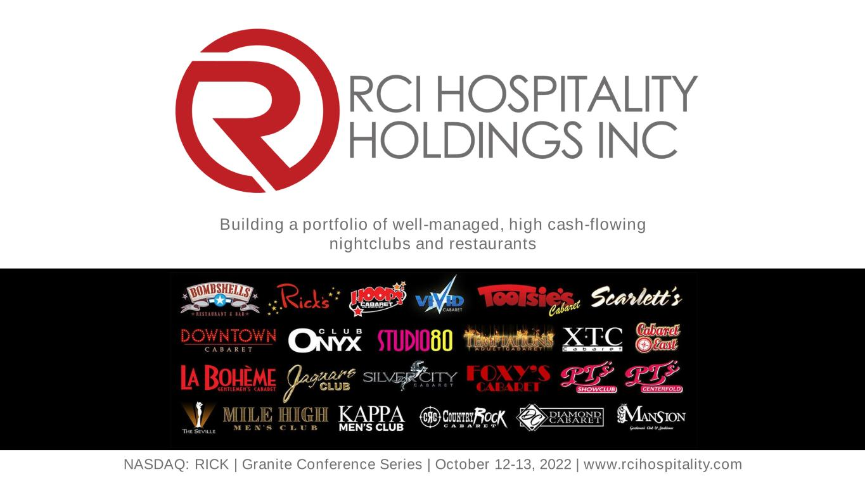
NASDAQ: RICK | Granite Conference Series | October 12-13, 2022 | www.rcihospitality.com Building a portfolio of well-managed, high cash-flowing nightclubs and restaurants

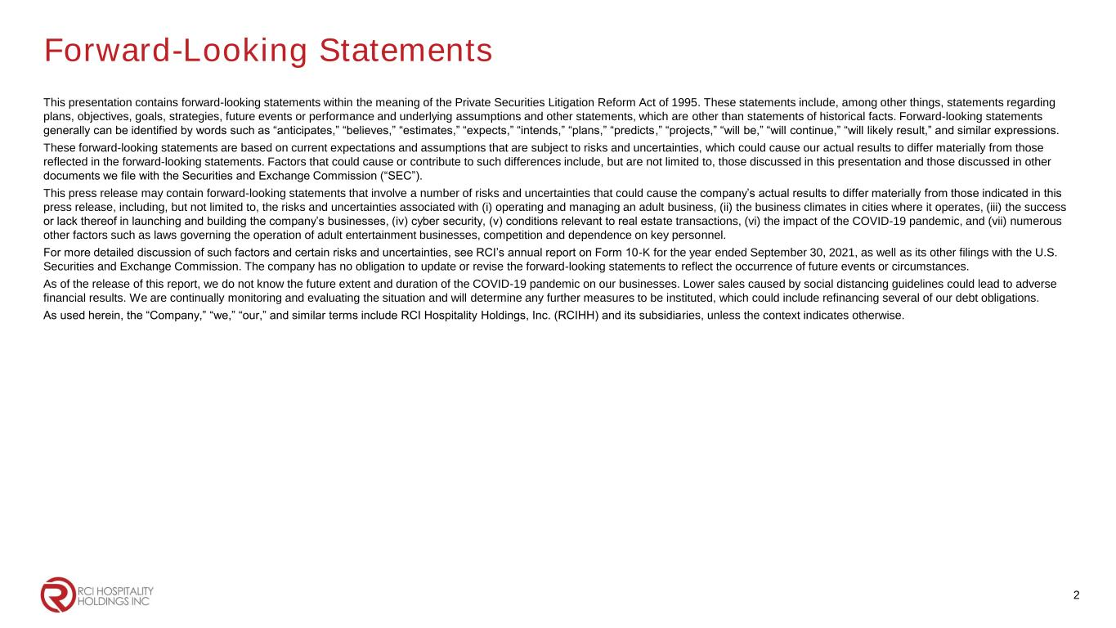
Forward-Looking Statements This presentation contains forward-looking statements within the meaning of the Private Securities Litigation Reform Act of 1995. These statements include, among other things, statements regarding plans, objectives, goals, strategies, future events or performance and underlying assumptions and other statements, which are other than statements of historical facts. Forward-looking statements generally can be identified by words such as “anticipates,” “believes,” “estimates,” “expects,” “intends,” “plans,” “predicts,” “projects,” “will be,” “will continue,” “will likely result,” and similar expressions. These forward-looking statements are based on current expectations and assumptions that are subject to risks and uncertainties, which could cause our actual results to differ materially from those reflected in the forward-looking statements. Factors that could cause or contribute to such differences include, but are not limited to, those discussed in this presentation and those discussed in other documents we file with the Securities and Exchange Commission (“SEC”). This press release may contain forward-looking statements that involve a number of risks and uncertainties that could cause the company’s actual results to differ materially from those indicated in this press release, including, but not limited to, the risks and uncertainties associated with (i) operating and managing an adult business, (ii) the business climates in cities where it operates, (iii) the success or lack thereof in launching and building the company’s businesses, (iv) cyber security, (v) conditions relevant to real estate transactions, (vi) the impact of the COVID-19 pandemic, and (vii) numerous other factors such as laws governing the operation of adult entertainment businesses, competition and dependence on key personnel. For more detailed discussion of such factors and certain risks and uncertainties, see RCI’s annual report on Form 10-K for the year ended September 30, 2021, as well as its other filings with the U.S. Securities and Exchange Commission. The company has no obligation to update or revise the forward-looking statements to reflect the occurrence of future events or circumstances. As of the release of this report, we do not know the future extent and duration of the COVID-19 pandemic on our businesses. Lower sales caused by social distancing guidelines could lead to adverse financial results. We are continually monitoring and evaluating the situation and will determine any further measures to be instituted, which could include refinancing several of our debt obligations. As used herein, the “Company,” “we,” “our,” and similar terms include RCI Hospitality Holdings, Inc. (RCIHH) and its subsidiaries, unless the context indicates otherwise. 2

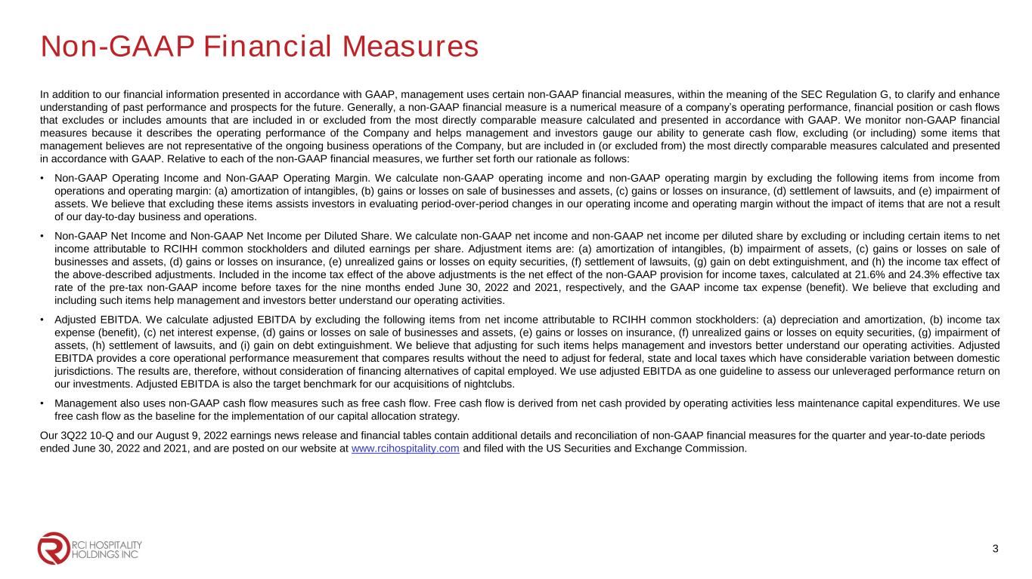
Non-GAAP Financial Measures In addition to our financial information presented in accordance with GAAP, management uses certain non-GAAP financial measures, within the meaning of the SEC Regulation G, to clarify and enhance understanding of past performance and prospects for the future. Generally, a non-GAAP financial measure is a numerical measure of a company’s operating performance, financial position or cash flows that excludes or includes amounts that are included in or excluded from the most directly comparable measure calculated and presented in accordance with GAAP. We monitor non-GAAP financial measures because it describes the operating performance of the Company and helps management and investors gauge our ability to generate cash flow, excluding (or including) some items that management believes are not representative of the ongoing business operations of the Company, but are included in (or excluded from) the most directly comparable measures calculated and presented in accordance with GAAP. Relative to each of the non-GAAP financial measures, we further set forth our rationale as follows: • Non-GAAP Operating Income and Non-GAAP Operating Margin. We calculate non-GAAP operating income and non-GAAP operating margin by excluding the following items from income from operations and operating margin: (a) amortization of intangibles, (b) gains or losses on sale of businesses and assets, (c) gains or losses on insurance, (d) settlement of lawsuits, and (e) impairment of assets. We believe that excluding these items assists investors in evaluating period-over-period changes in our operating income and operating margin without the impact of items that are not a result of our day-to-day business and operations. • Non-GAAP Net Income and Non-GAAP Net Income per Diluted Share. We calculate non-GAAP net income and non-GAAP net income per diluted share by excluding or including certain items to net income attributable to RCIHH common stockholders and diluted earnings per share. Adjustment items are: (a) amortization of intangibles, (b) impairment of assets, (c) gains or losses on sale of businesses and assets, (d) gains or losses on insurance, (e) unrealized gains or losses on equity securities, (f) settlement of lawsuits, (g) gain on debt extinguishment, and (h) the income tax effect of the above-described adjustments. Included in the income tax effect of the above adjustments is the net effect of the non-GAAP provision for income taxes, calculated at 21.6% and 24.3% effective tax rate of the pre-tax non-GAAP income before taxes for the nine months ended June 30, 2022 and 2021, respectively, and the GAAP income tax expense (benefit). We believe that excluding and including such items help management and investors better understand our operating activities. • Adjusted EBITDA. We calculate adjusted EBITDA by excluding the following items from net income attributable to RCIHH common stockholders: (a) depreciation and amortization, (b) income tax expense (benefit), (c) net interest expense, (d) gains or losses on sale of businesses and assets, (e) gains or losses on insurance, (f) unrealized gains or losses on equity securities, (g) impairment of assets, (h) settlement of lawsuits, and (i) gain on debt extinguishment. We believe that adjusting for such items helps management and investors better understand our operating activities. Adjusted EBITDA provides a core operational performance measurement that compares results without the need to adjust for federal, state and local taxes which have considerable variation between domestic jurisdictions. The results are, therefore, without consideration of financing alternatives of capital employed. We use adjusted EBITDA as one guideline to assess our unleveraged performance return on our investments. Adjusted EBITDA is also the target benchmark for our acquisitions of nightclubs. • Management also uses non-GAAP cash flow measures such as free cash flow. Free cash flow is derived from net cash provided by operating activities less maintenance capital expenditures. We use free cash flow as the baseline for the implementation of our capital allocation strategy. Our 3Q22 10-Q and our August 9, 2022 earnings news release and financial tables contain additional details and reconciliation of non-GAAP financial measures for the quarter and year-to-date periods ended June 30, 2022 and 2021, and are posted on our website at www.rcihospitality.com and filed with the US Securities and Exchange Commission. 3

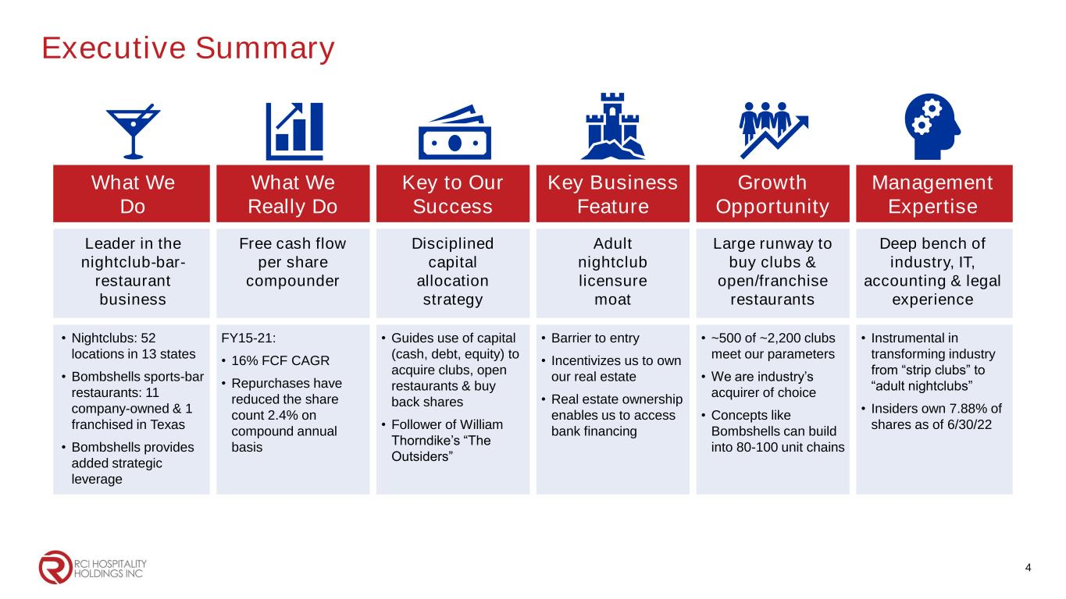
Executive Summary What We Do What We Really Do Key to Our Success Key Business Feature Growth Opportunity Management Expertise Leader in the nightclub-bar- restaurant business Free cash flow per share compounder Disciplined capital allocation strategy Adult nightclub licensure moat Large runway to buy clubs & open/franchise restaurants Deep bench of industry, IT, accounting & legal experience • Nightclubs: 52 locations in 13 states • Bombshells sports-bar restaurants: 11 company-owned & 1 franchised in Texas • Bombshells provides added strategic leverage FY15-21: • 16% FCF CAGR • Repurchases have reduced the share count 2.4% on compound annual basis • Guides use of capital (cash, debt, equity) to acquire clubs, open restaurants & buy back shares • Follower of William Thorndike’s “The Outsiders” • Barrier to entry • Incentivizes us to own our real estate • Real estate ownership enables us to access bank financing • ~500 of ~2,200 clubs meet our parameters • We are industry’s acquirer of choice • Concepts like Bombshells can build into 80-100 unit chains • Instrumental in transforming industry from “strip clubs” to “adult nightclubs” • Insiders own 7.88% of shares as of 6/30/22 4

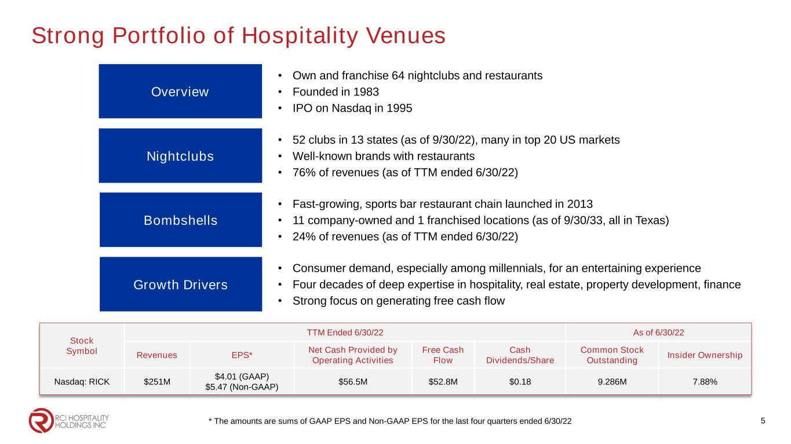
Strong Portfolio of Hospitality Venues Nightclubs • 52 clubs in 13 states (as of 9/30/22), many in top 20 US markets • Well-known brands with restaurants • 76% of revenues (as of TTM ended 6/30/22) Overview • Own and franchise 64 nightclubs and restaurants • Founded in 1983 • IPO on Nasdaq in 1995 Growth Drivers • Consumer demand, especially among millennials, for an entertaining experience • Four decades of deep expertise in hospitality, real estate, property development, finance • Strong focus on generating free cash flow Bombshells • Fast-growing, sports bar restaurant chain launched in 2013 • 11 company-owned and 1 franchised locations (as of 9/30/33, all in Texas) • 24% of revenues (as of TTM ended 6/30/22) Stock Symbol TTM Ended 6/30/22 As of 6/30/22 Revenues EPS* Net Cash Provided by Operating Activities Free Cash Flow Cash Dividends/Share Common Stock Outstanding Insider Ownership Nasdaq: RICK $251M $4.01 (GAAP) $5.47 (Non-GAAP) $56.5M $52.8M $0.18 9.286M 7.88% 5* The amounts are sums of GAAP EPS and Non-GAAP EPS for the last four quarters ended 6/30/22

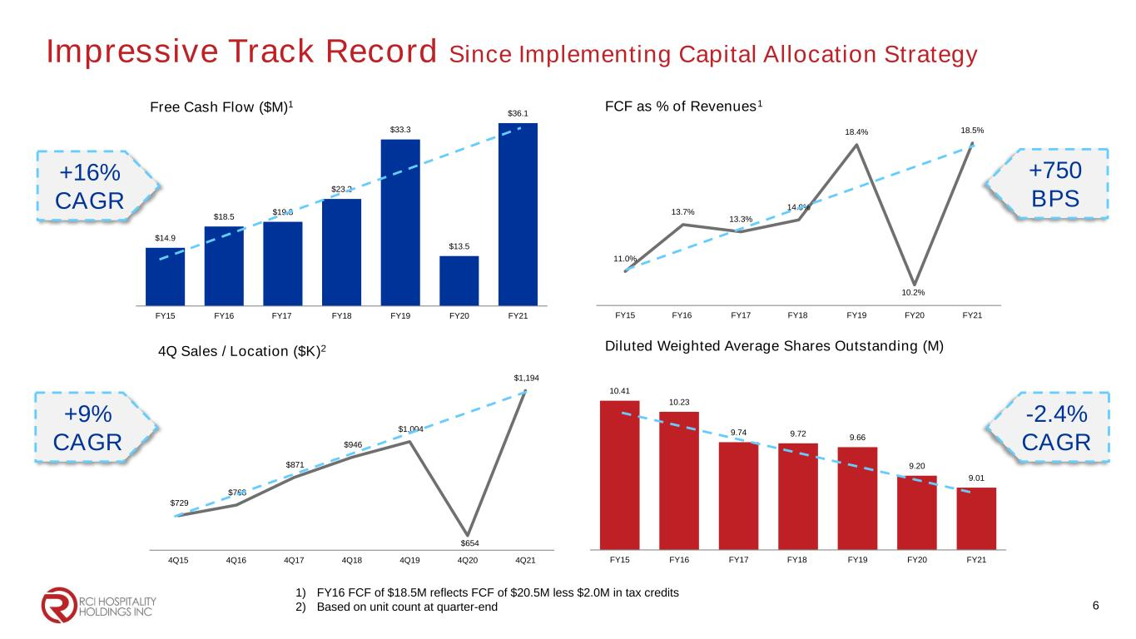
10.41 10.23 9.74 9.72 9.66 9.20 9.01 FY15 FY16 FY17 FY18 FY19 FY20 FY21 Impressive Track Record Since Implementing Capital Allocation Strategy $14.9 $18.5 $19.3 $23.2 $33.3 $13.5 $36.1 FY15 FY16 FY17 FY18 FY19 FY20 FY21 Free Cash Flow ($M)1 11.0% 13.7% 13.3% 14.0% 18.4% 10.2% 18.5% FY15 FY16 FY17 FY18 FY19 FY20 FY21 FCF as % of Revenues1 Diluted Weighted Average Shares Outstanding (M) 1) FY16 FCF of $18.5M reflects FCF of $20.5M less $2.0M in tax credits 2) Based on unit count at quarter-end $729 $768 $871 $946 $1,004 $654 $1,194 4Q15 4Q16 4Q17 4Q18 4Q19 4Q20 4Q21 4Q Sales / Location ($K)2 6 +16% CAGR +9% CAGR +750 BPS -2.4% CAGR

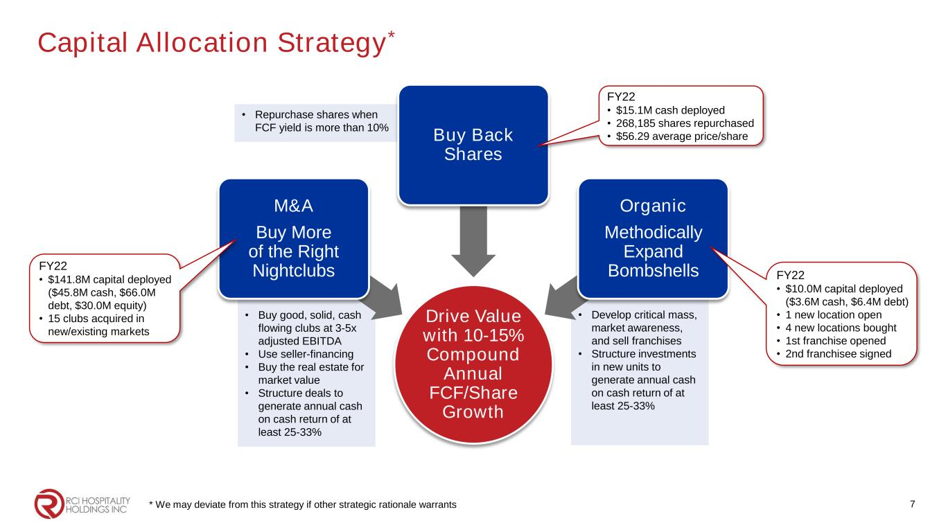
Capital Allocation Strategy* * We may deviate from this strategy if other strategic rationale warrants • Repurchase shares when FCF yield is more than 10% • Develop critical mass, market awareness, and sell franchises • Structure investments in new units to generate annual cash on cash return of at least 25-33% • Buy good, solid, cash flowing clubs at 3-5x adjusted EBITDA • Use seller-financing • Buy the real estate for market value • Structure deals to generate annual cash on cash return of at least 25-33% Drive Value with 10-15% Compound Annual FCF/Share Growth M&A Buy More of the Right Nightclubs Buy Back Shares Organic Methodically Expand Bombshells 7 FY22 • $15.1M cash deployed • 268,185 shares repurchased • $56.29 average price/share FY22 • $10.0M capital deployed ($3.6M cash, $6.4M debt) • 1 new location open • 4 new locations bought • 1st franchise opened • 2nd franchisee signed FY22 • $141.8M capital deployed ($45.8M cash, $66.0M debt, $30.0M equity) • 15 clubs acquired in new/existing markets

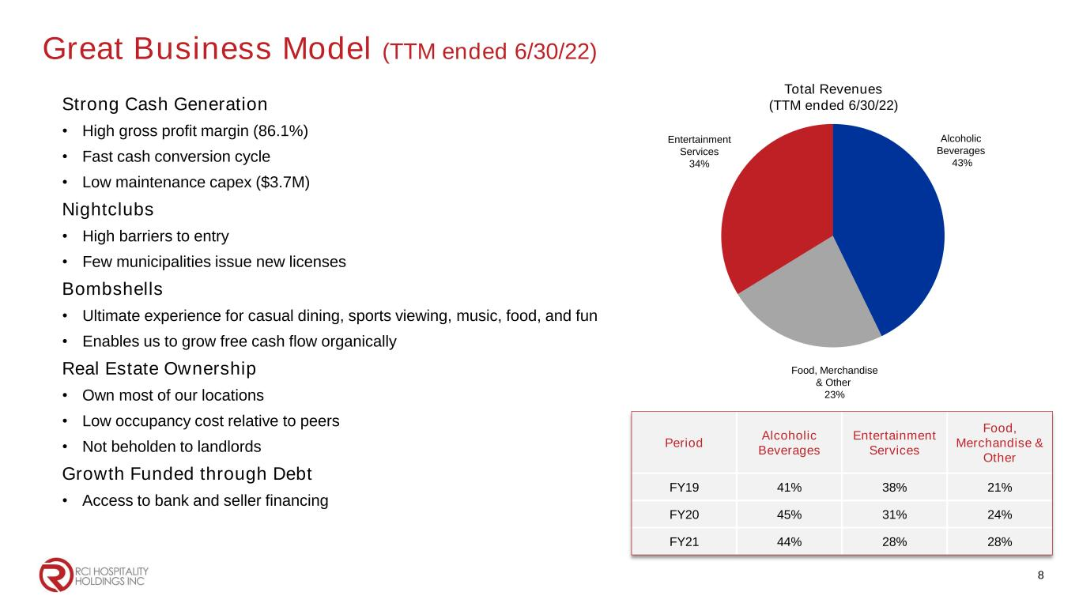
Great Business Model (TTM ended 6/30/22) Strong Cash Generation • High gross profit margin (86.1%) • Fast cash conversion cycle • Low maintenance capex ($3.7M) Nightclubs • High barriers to entry • Few municipalities issue new licenses Bombshells • Ultimate experience for casual dining, sports viewing, music, food, and fun • Enables us to grow free cash flow organically Real Estate Ownership • Own most of our locations • Low occupancy cost relative to peers • Not beholden to landlords Growth Funded through Debt • Access to bank and seller financing Total Revenues (TTM ended 6/30/22) Alcoholic Beverages 43% Entertainment Services 34% Food, Merchandise & Other 23% Period Alcoholic Beverages Entertainment Services Food, Merchandise & Other FY19 41% 38% 21% FY20 45% 31% 24% FY21 44% 28% 28% 8

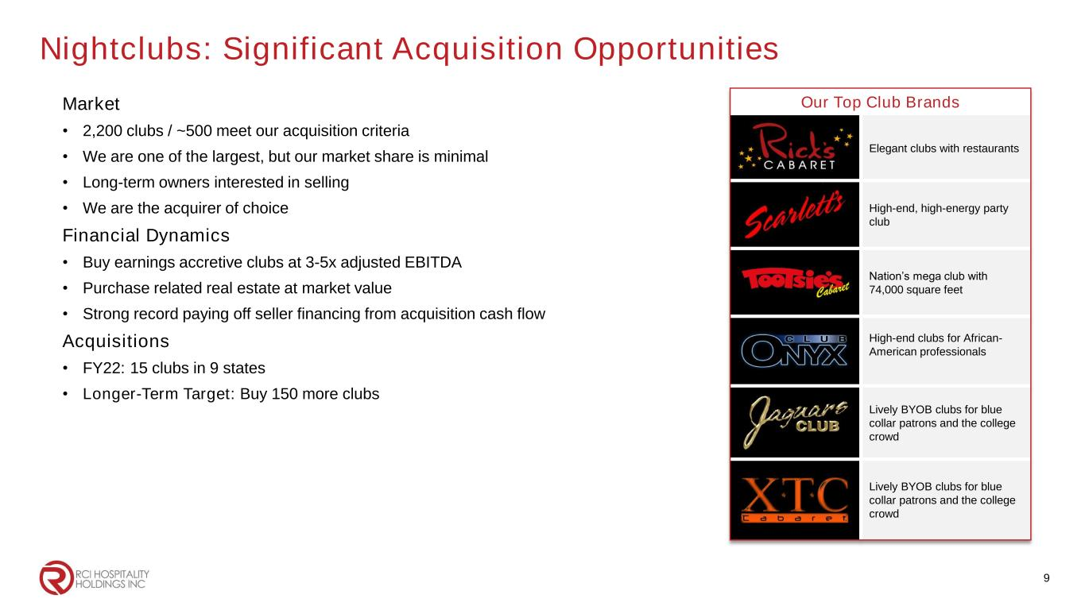
Nightclubs: Significant Acquisition Opportunities Market • 2,200 clubs / ~500 meet our acquisition criteria • We are one of the largest, but our market share is minimal • Long-term owners interested in selling • We are the acquirer of choice Financial Dynamics • Buy earnings accretive clubs at 3-5x adjusted EBITDA • Purchase related real estate at market value • Strong record paying off seller financing from acquisition cash flow Acquisitions • FY22: 15 clubs in 9 states • Longer-Term Target: Buy 150 more clubs Our Top Club Brands Elegant clubs with restaurants High-end, high-energy party club Nation’s mega club with 74,000 square feet High-end clubs for African- American professionals Lively BYOB clubs for blue collar patrons and the college crowd Lively BYOB clubs for blue collar patrons and the college crowd 9

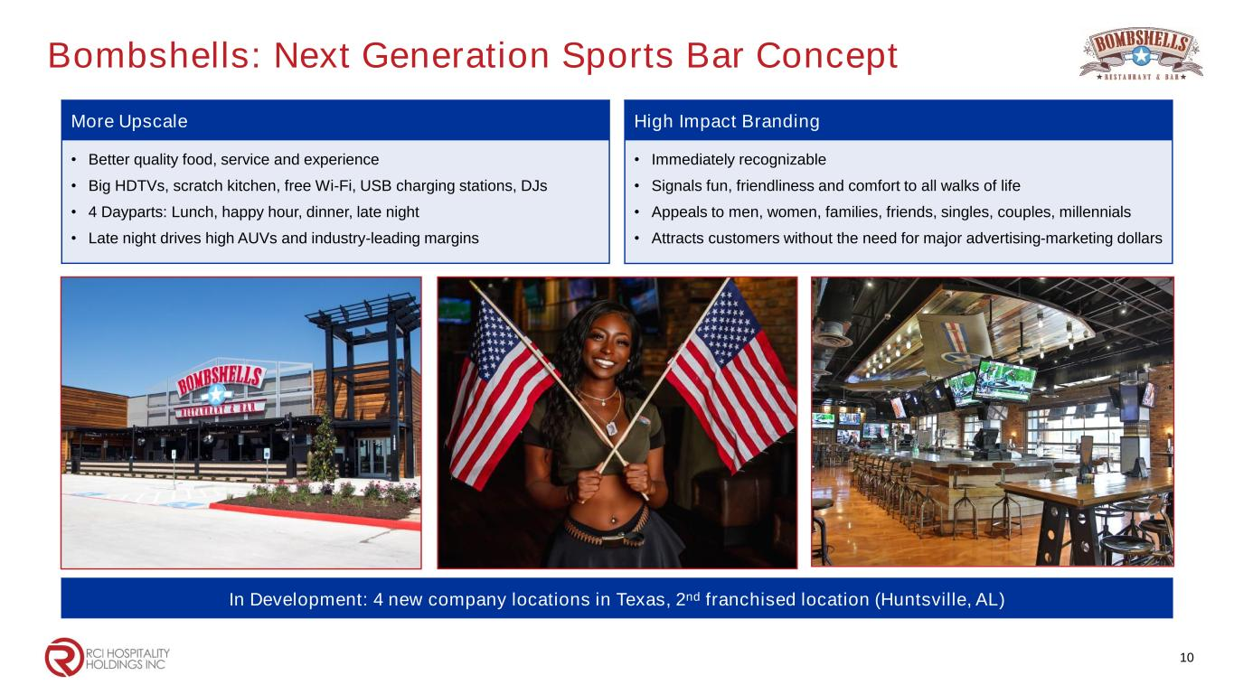
Bombshells: Next Generation Sports Bar Concept More Upscale • Better quality food, service and experience • Big HDTVs, scratch kitchen, free Wi-Fi, USB charging stations, DJs • 4 Dayparts: Lunch, happy hour, dinner, late night • Late night drives high AUVs and industry-leading margins 10 High Impact Branding • Immediately recognizable • Signals fun, friendliness and comfort to all walks of life • Appeals to men, women, families, friends, singles, couples, millennials • Attracts customers without the need for major advertising-marketing dollars In Development: 4 new company locations in Texas, 2nd franchised location (Huntsville, AL)

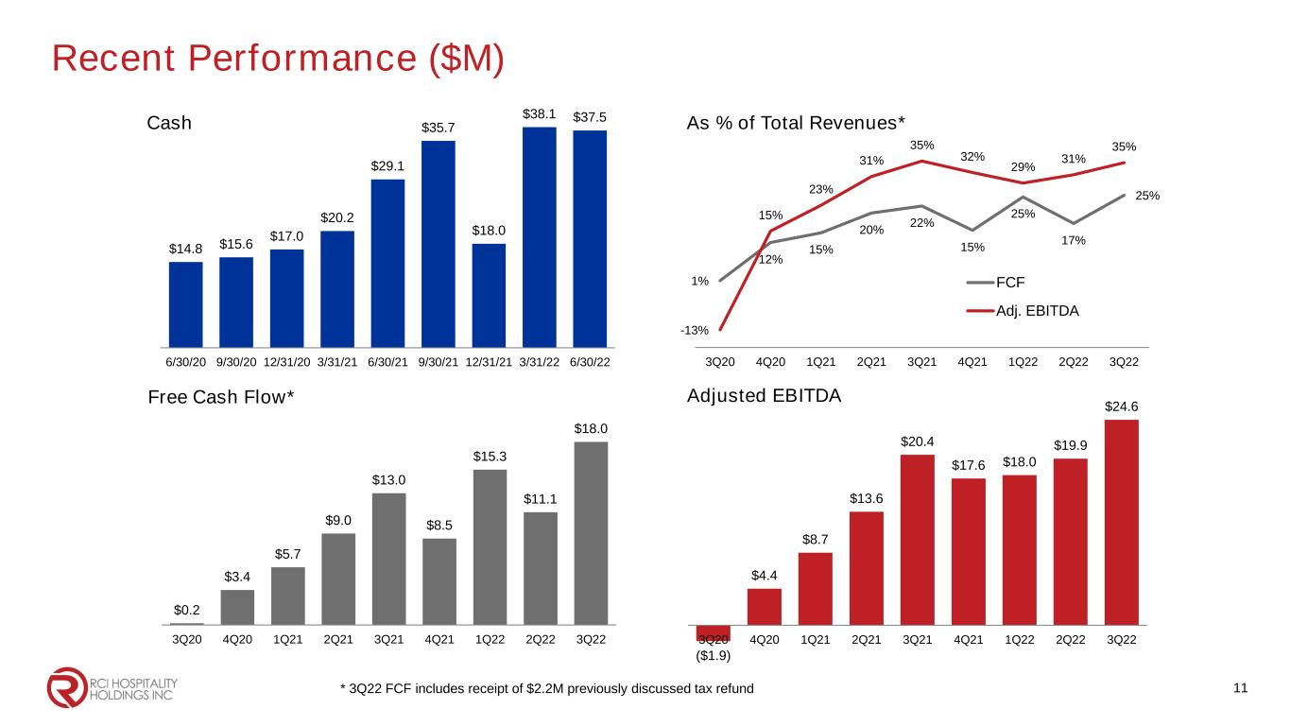
1% 12% 15% 20% 22% 15% 25% 17% 25% -13% 15% 23% 31% 35% 32% 29% 31% 35% 3Q20 4Q20 1Q21 2Q21 3Q21 4Q21 1Q22 2Q22 3Q22 FCF Adj. EBITDA ($1.9) $4.4 $8.7 $13.6 $20.4 $17.6 $18.0 $19.9 $24.6 3Q20 4Q20 1Q21 2Q21 3Q21 4Q21 1Q22 2Q22 3Q22 Recent Performance ($M) $14.8 $15.6 $17.0 $20.2 $29.1 $35.7 $18.0 $38.1 $37.5 6/30/20 9/30/20 12/31/20 3/31/21 6/30/21 9/30/21 12/31/21 3/31/22 6/30/22 Cash As % of Total Revenues* Adjusted EBITDA $0.2 $3.4 $5.7 $9.0 $13.0 $8.5 $15.3 $11.1 $18.0 3Q20 4Q20 1Q21 2Q21 3Q21 4Q21 1Q22 2Q22 3Q22 Free Cash Flow* 11* 3Q22 FCF includes receipt of $2.2M previously discussed tax refund

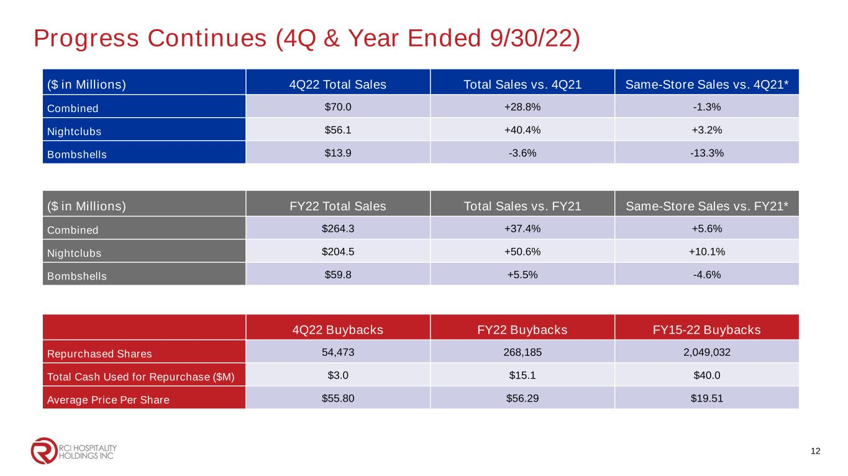
Progress Continues (4Q & Year Ended 9/30/22) 12 ($ in Millions) 4Q22 Total Sales Total Sales vs. 4Q21 Same-Store Sales vs. 4Q21* Combined $70.0 +28.8% -1.3% Nightclubs $56.1 +40.4% +3.2% Bombshells $13.9 -3.6% -13.3% ($ in Millions) FY22 Total Sales Total Sales vs. FY21 Same-Store Sales vs. FY21* Combined $264.3 +37.4% +5.6% Nightclubs $204.5 +50.6% +10.1% Bombshells $59.8 +5.5% -4.6% 4Q22 Buybacks FY22 Buybacks FY15-22 Buybacks Repurchased Shares 54,473 268,185 2,049,032 Total Cash Used for Repurchase ($M) $3.0 $15.1 $40.0 Average Price Per Share $55.80 $56.29 $19.51

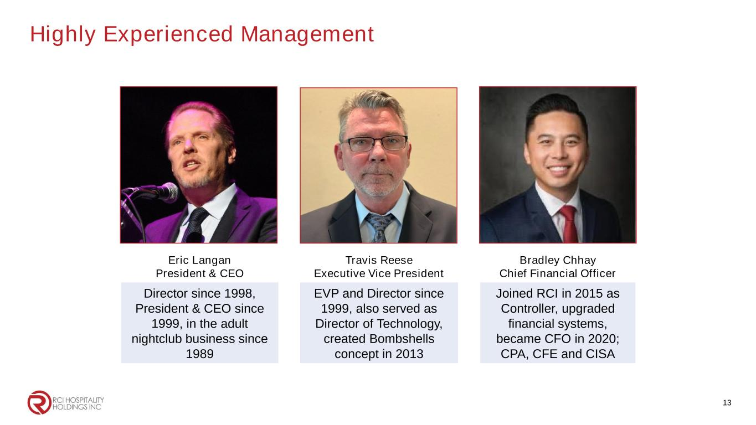
Highly Experienced Management 13 Eric Langan President & CEO Travis Reese Executive Vice President Bradley Chhay Chief Financial Officer Director since 1998, President & CEO since 1999, in the adult nightclub business since 1989 EVP and Director since 1999, also served as Director of Technology, created Bombshells concept in 2013 Joined RCI in 2015 as Controller, upgraded financial systems, became CFO in 2020; CPA, CFE and CISA


Corporate Office 10737 Cutten Road Houston, TX 77066 Phone: (281) 397-6730 Investor Relations Gary Fishman Steven Anreder Phone: (212) 532-3232 IR Website www.rcihospitality.com Nasdaq: RICK Contact Information 14

