United States
Securities and Exchange Commission
Washington, D.C. 20549
FORM 8-K
Current Report
Pursuant to Section 13 or 15(d) of
The Securities Exchange Act of 1934
Date of Report (Date of earliest event reported): January 10, 2023
RCI HOSPITALITY HOLDINGS, INC.
(Exact Name of Registrant as Specified in Its Charter)

Texas |  |  | 001-13992 |  |  | 76-0458229
(State or Other Jurisdiction  of Incorporation) |  |  | (Commission  File Number) |  |  | (IRS Employer  Identification No.)
10737 Cutten Road
Houston, Texas 77066
(Address of Principal Executive Offices, Including Zip Code)
(281) 397-6730
(Issuer’s Telephone Number, Including Area Code)
Check the appropriate box below if the Form 8-K filing is intended to simultaneously satisfy the filing obligation of the registrant under any of the following provisions:

o |  |  | Written communications pursuant to Rule 425 under the Securities Act (17 CFR 230.425)
o |  |  | Soliciting material pursuant to Rule 14a-12 under the Exchange Act (17 CFR 240.14a -12)
o |  |  | Pre-commencement communications pursuant to Rule 14d-2(b) under the Exchange Act (17 CFR 240.14d -2(b))
o |  |  | Pre-commencement communications pursuant to Rule 13e-4(c) under the Exchange Act (17 CFR 240.13e -4(c))
Securities registered pursuant to Section 12(b) of the Act:

Title of each class |  |  |  |  |  | Trading Symbol(s) |  |  |  |  |  | Name of each exchange on which registered
Common stock, $0.01 par value |  |  |  |  |  | RICK |  |  |  |  |  | The Nasdaq Global Market
Indicate by check mark whether the registrant is an emerging growth company as defined in Rule 405 of the Securities Act of 1933 (§230.405 of this chapter) or Rule 12b-2 of the Securities Exchange Act of 1934 (§240.12b-2 of this chapter).
Emerging growth company o
If an emerging growth company, indicate by check mark if the registrant has elected not to use the extended transition period for complying with any new or revised financial accounting standards provided pursuant to Section 13(a) of the Exchange Act. o

ITEM 2.02 RESULTS OF OPERATIONS AND FINANCIAL CONDITION.

On January 10, 2023, we issued a press release announcing sales at nightclubs and restaurants for the first fiscal quarter ended December 31, 2022. A copy of the press release is furnished as Exhibit 99.1 to this current report on Form 8-K.
On January 11 and 12, 2023, we will be meeting with investors via the Granite Research Virtual Conference Series. A copy of the presentation slides that may be used in whole or in part at those meetings is furnished with this current report as Exhibit 99.2.

ITEM 7.01 REGULATION FD DISCLOSURE.

The disclosure in Item 2.02 above is incorporated herein by reference.

The furnishing of the attached presentation slides is not an admission as to the materiality of any information therein. The information contained in the slides is summary information that is intended to be considered in the context of more complete information included in our filings with the U.S. Securities and Exchange Commission (the “SEC”) and other public announcements that we have made and may make from time to time by press release or otherwise. We undertake no duty or obligation to update or revise the information contained in this report, although we may do so from time to time as management believes is appropriate. Any such updating may be made through the filing of other reports or documents with the SEC, through press releases or through other public disclosures. For important information about forward looking statements, see the slide titled “Forward-Looking Statements” in Exhibit 99.2 included herewith.

The information in this current report on Form 8-K, including Exhibit 99.1 and Exhibit 99.2, is being furnished and will not be treated as “filed” for the purposes of Section 18 of the Securities Exchange Act of 1934, as amended, or otherwise subject to the liabilities of that section.

ITEM 9.01 FINANCIAL STATEMENTS AND EXHIBITS

(d) Exhibits

Exhibit Number |  |  |  |  |  | Description
99.1 |  |  |  |  |  | Press release of RCI Hospitality Holdings, Inc. dated January 10, 2023
99.2 |  |  |  |  |  | Presentation Slides - Investor Presentation
104 |  |  |  |  |  | Cover Page Interactive Data File (embedded within the Inline XBRL document)
2

SIGNATURES
Pursuant to the requirements of the Securities Exchange Act of 1934, the registrant has duly caused this report to be signed on its behalf by the undersigned hereunto duly authorized.

 |  |  | RCI HOSPITALITY HOLDINGS, INC.
Date: January 11, 2023 |  |  | By: |  |  | /s/ Eric Langan
 |  |  |  |  |  | Eric Langan
 |  |  |  |  |  | President and Chief Executive Officer
3

Exhibit 99.1

RCI Reports 1Q23 Club & Restaurant Sales
HOUSTON—January 10, 2023—RCI Hospitality Holdings, Inc. (Nasdaq: RICK) reported sales for its Nightclubs and Bombshells restaurants of $69.2 million for the fiscal first quarter ended December 31, 2022, a 13.3% year-over-year increase. Sales do not include non-core operations and are preliminary and subject to final closing. Full 1Q23 financial results are expected by February 9.
Eric Langan, President & CEO of RCI, said: “As we indicated on our most recent conference call, nightclub sales remained high, reflecting strong contributions from acquisitions, increased VIP spend at many of our northern clubs, and reopened/reformatted clubs, all of which more than offset intermittent softness at some blue collar clubs compared to a year-ago. Also as we discussed, Bombshells faced difficult comparisons to the last year and a half when they benefited from a highly favorable macro-economic environment. Despite that, Bombshells 1Q23 average unit volume of $1.2 million was 5.2% higher compared to pre-COVID 1Q20. Looking ahead, FY22 club acquisitions will begin rolling into SSS in 2Q23. The segment should also benefit from full quarters of more recent acquisitions, and Bombshells should significantly improve as new locations open in FY24.”
Club & Restaurant Sales ($ in Millions)

 |  |  | 1Q23 Total Sales |  |  | Total Sales vs. 1Q22 |  |  | Same-Store Sales vs. 1Q22 |  |  | SSS vs. 1Q20
Combined |  |  | $69.2 |  |  | +13.3% |  |  | -2.7% |  |  | +8.6%
Nightclubs |  |  | $55.9 |  |  | +20.7% |  |  | +1.2% |  |  | +10.0%
Bombshells |  |  | $13.3 |  |  | -9.7% |  |  | -13.9% |  |  | +3.6%
Notes
•1Q23 club sales included $15.3 million from the 15 clubs acquired in FY22 and one of the two clubs acquired in 1Q23. The other club will reopen later this year. Recently, RCI announced agreements to acquire five more clubs which should close in 2Q23.
•1Q23 club sales also included results from three renamed and reformatted clubs: Scarlett’s Cabaret Louisiana, which opened March 2022; Scarlett’s Cabaret San Antonio, which opened August 2022; and Jaguars Club San Antonio, which opened late December 2022.
•1Q23 restaurant sales included $1.3 million from Bombshells Arlington, which opened December 2021, and a small contribution from Grange Food Hall, which was acquired late December 2022.
•RCI bought back 1,500 shares for $97,530 at an average price per share of $65.02 in 1Q23.
•The COVID pandemic first impacted sales in RCI’s 2Q20 when all locations were required to close mid-March 2020. By May 2020, Bombshells and some nightclubs began to reopen, but all clubs were not fully reopened to their full operating hours until 4Q21. 1Q23 was the third period since 1Q20 not affected by COVID.
•Revenues from non-core operations, such as third-party rents, Bombshells franchise fees, and Other segment revenues, are not included in Nightclubs and Bombshells sales above.
•All references to “RCI Hospitality Holdings, Inc.,” “company,” “we,” “our,” and similar terms refer to RCI and/or its subsidiaries, unless the context indicates otherwise.
About RCI Hospitality Holdings, Inc. (Nasdaq: RICK) (Twitter: @RCIHHinc)
With more than 60 locations, RCI Hospitality Holdings, Inc., through its subsidiaries, is the country’s leading company in adult nightclubs and sports bars/restaurants. See all our brands at www.rcihospitality.com.
1

Forward-Looking Statements
This press release may contain forward-looking statements that involve a number of risks and uncertainties that could cause the company's actual results to differ materially from those indicated, including, but not limited to, the risks and uncertainties associated with (i) operating and managing an adult entertainment or restaurant business, (ii) the business climates in cities where it operates, (iii) the success or lack thereof in launching and building the company's businesses, (iv) cyber security, (v) conditions relevant to real estate transactions, (vi) the impact of the COVID-19 pandemic, and (vii) numerous other factors such as laws governing the operation of adult entertainment or restaurant businesses, competition and dependence on key personnel. For more detailed discussion of such factors and certain risks and uncertainties, see RCI's annual report on Form 10-K for the year ended September 30, 2022, as well as its other filings with the U.S. Securities and Exchange Commission. The company has no obligation to update or revise the forward-looking statements to reflect the occurrence of future events or circumstances.
Media & Investor Contacts
Gary Fishman and Steven Anreder at 212-532-3232 or gary.fishman@anreder.com and steven.anreder@anreder.com
2

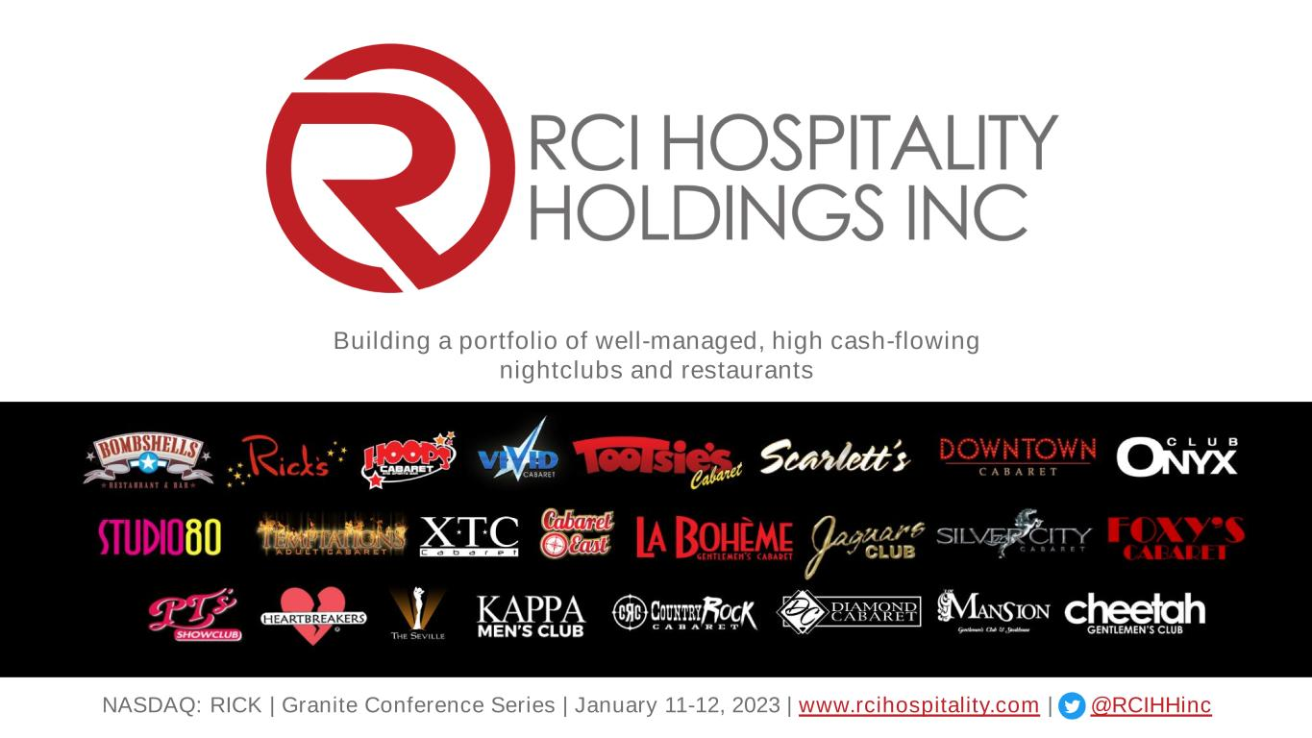
NASDAQ: RICK | Granite Conference Series | January 11-12, 2023 | www.rcihospitality.com | @RCIHHinc Building a portfolio of well-managed, high cash-flowing nightclubs and restaurants

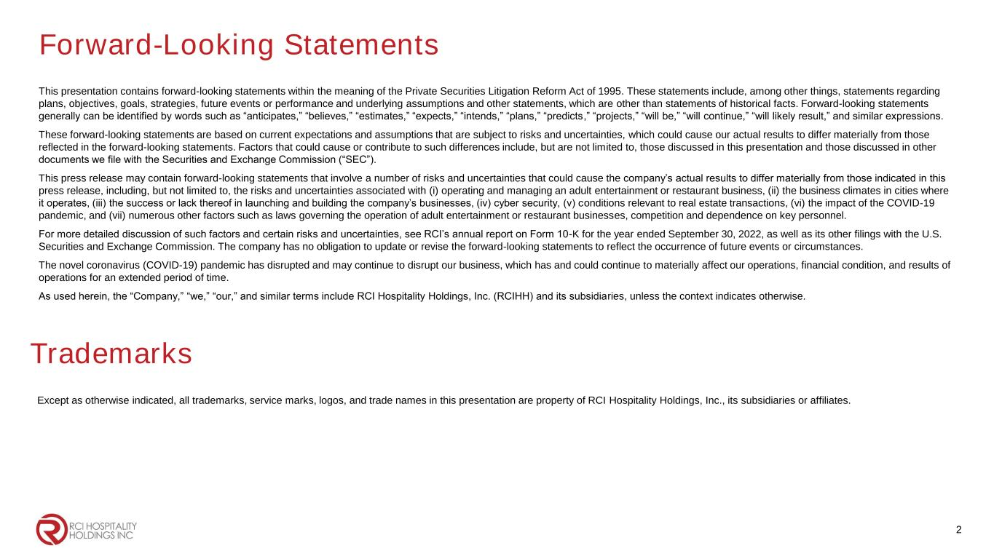
Forward-Looking Statements This presentation contains forward-looking statements within the meaning of the Private Securities Litigation Reform Act of 1995. These statements include, among other things, statements regarding plans, objectives, goals, strategies, future events or performance and underlying assumptions and other statements, which are other than statements of historical facts. Forward-looking statements generally can be identified by words such as “anticipates,” “believes,” “estimates,” “expects,” “intends,” “plans,” “predicts,” “projects,” “will be,” “will continue,” “will likely result,” and similar expressions. These forward-looking statements are based on current expectations and assumptions that are subject to risks and uncertainties, which could cause our actual results to differ materially from those reflected in the forward-looking statements. Factors that could cause or contribute to such differences include, but are not limited to, those discussed in this presentation and those discussed in other documents we file with the Securities and Exchange Commission (“SEC”). This press release may contain forward-looking statements that involve a number of risks and uncertainties that could cause the company’s actual results to differ materially from those indicated in this press release, including, but not limited to, the risks and uncertainties associated with (i) operating and managing an adult entertainment or restaurant business, (ii) the business climates in cities where it operates, (iii) the success or lack thereof in launching and building the company’s businesses, (iv) cyber security, (v) conditions relevant to real estate transactions, (vi) the impact of the COVID-19 pandemic, and (vii) numerous other factors such as laws governing the operation of adult entertainment or restaurant businesses, competition and dependence on key personnel. For more detailed discussion of such factors and certain risks and uncertainties, see RCI’s annual report on Form 10-K for the year ended September 30, 2022, as well as its other filings with the U.S. Securities and Exchange Commission. The company has no obligation to update or revise the forward-looking statements to reflect the occurrence of future events or circumstances. The novel coronavirus (COVID-19) pandemic has disrupted and may continue to disrupt our business, which has and could continue to materially affect our operations, financial condition, and results of operations for an extended period of time. As used herein, the “Company,” “we,” “our,” and similar terms include RCI Hospitality Holdings, Inc. (RCIHH) and its subsidiaries, unless the context indicates otherwise. 2 Trademarks Except as otherwise indicated, all trademarks, service marks, logos, and trade names in this presentation are property of RCI Hospitality Holdings, Inc., its subsidiaries or affiliates.

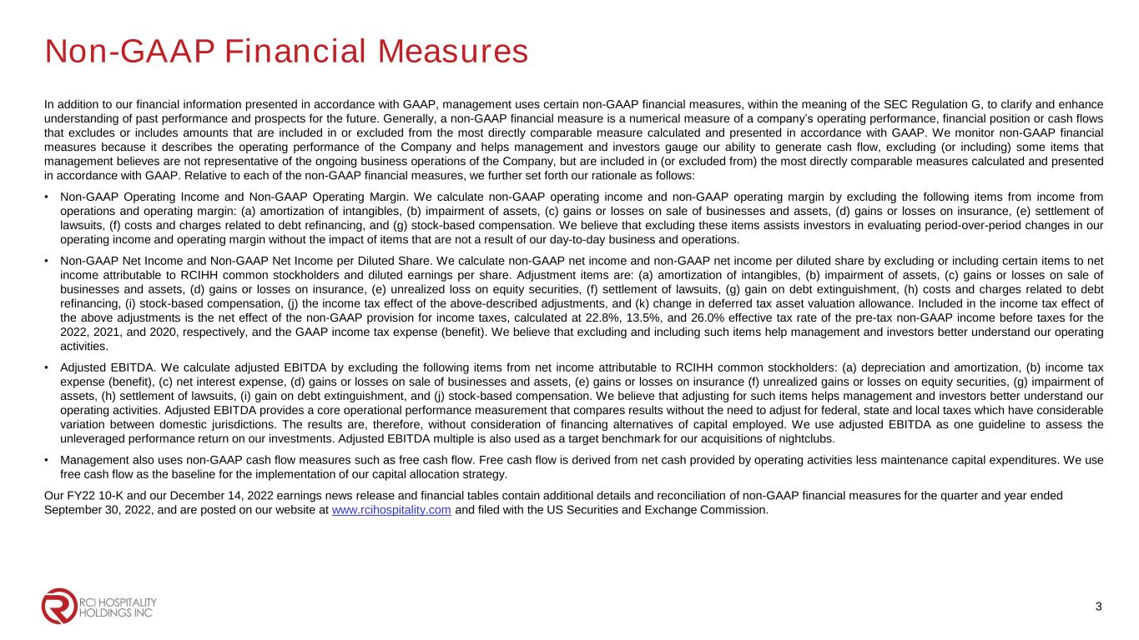
Non-GAAP Financial Measures In addition to our financial information presented in accordance with GAAP, management uses certain non-GAAP financial measures, within the meaning of the SEC Regulation G, to clarify and enhance understanding of past performance and prospects for the future. Generally, a non-GAAP financial measure is a numerical measure of a company’s operating performance, financial position or cash flows that excludes or includes amounts that are included in or excluded from the most directly comparable measure calculated and presented in accordance with GAAP. We monitor non-GAAP financial measures because it describes the operating performance of the Company and helps management and investors gauge our ability to generate cash flow, excluding (or including) some items that management believes are not representative of the ongoing business operations of the Company, but are included in (or excluded from) the most directly comparable measures calculated and presented in accordance with GAAP. Relative to each of the non-GAAP financial measures, we further set forth our rationale as follows: • Non-GAAP Operating Income and Non-GAAP Operating Margin. We calculate non-GAAP operating income and non-GAAP operating margin by excluding the following items from income from operations and operating margin: (a) amortization of intangibles, (b) impairment of assets, (c) gains or losses on sale of businesses and assets, (d) gains or losses on insurance, (e) settlement of lawsuits, (f) costs and charges related to debt refinancing, and (g) stock-based compensation. We believe that excluding these items assists investors in evaluating period-over-period changes in our operating income and operating margin without the impact of items that are not a result of our day-to-day business and operations. • Non-GAAP Net Income and Non-GAAP Net Income per Diluted Share. We calculate non-GAAP net income and non-GAAP net income per diluted share by excluding or including certain items to net income attributable to RCIHH common stockholders and diluted earnings per share. Adjustment items are: (a) amortization of intangibles, (b) impairment of assets, (c) gains or losses on sale of businesses and assets, (d) gains or losses on insurance, (e) unrealized loss on equity securities, (f) settlement of lawsuits, (g) gain on debt extinguishment, (h) costs and charges related to debt refinancing, (i) stock-based compensation, (j) the income tax effect of the above-described adjustments, and (k) change in deferred tax asset valuation allowance. Included in the income tax effect of the above adjustments is the net effect of the non-GAAP provision for income taxes, calculated at 22.8%, 13.5%, and 26.0% effective tax rate of the pre-tax non-GAAP income before taxes for the 2022, 2021, and 2020, respectively, and the GAAP income tax expense (benefit). We believe that excluding and including such items help management and investors better understand our operating activities. • Adjusted EBITDA. We calculate adjusted EBITDA by excluding the following items from net income attributable to RCIHH common stockholders: (a) depreciation and amortization, (b) income tax expense (benefit), (c) net interest expense, (d) gains or losses on sale of businesses and assets, (e) gains or losses on insurance (f) unrealized gains or losses on equity securities, (g) impairment of assets, (h) settlement of lawsuits, (i) gain on debt extinguishment, and (j) stock-based compensation. We believe that adjusting for such items helps management and investors better understand our operating activities. Adjusted EBITDA provides a core operational performance measurement that compares results without the need to adjust for federal, state and local taxes which have considerable variation between domestic jurisdictions. The results are, therefore, without consideration of financing alternatives of capital employed. We use adjusted EBITDA as one guideline to assess the unleveraged performance return on our investments. Adjusted EBITDA multiple is also used as a target benchmark for our acquisitions of nightclubs. • Management also uses non-GAAP cash flow measures such as free cash flow. Free cash flow is derived from net cash provided by operating activities less maintenance capital expenditures. We use free cash flow as the baseline for the implementation of our capital allocation strategy. Our FY22 10-K and our December 14, 2022 earnings news release and financial tables contain additional details and reconciliation of non-GAAP financial measures for the quarter and year ended September 30, 2022, and are posted on our website at www.rcihospitality.com and filed with the US Securities and Exchange Commission. 3

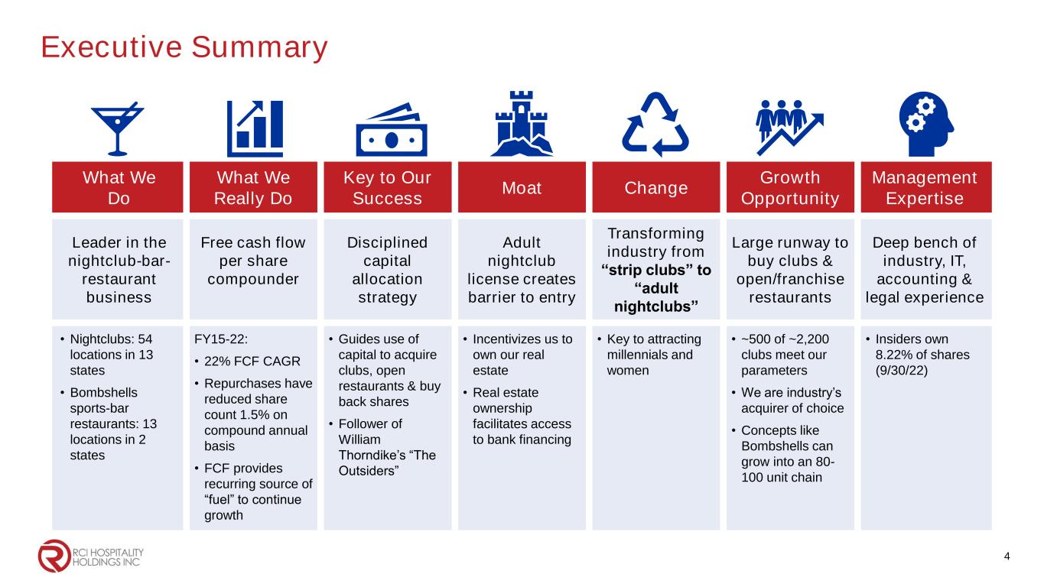
Executive Summary What We Do What We Really Do Key to Our Success Moat Change Growth Opportunity Management Expertise Leader in the nightclub-bar- restaurant business Free cash flow per share compounder Disciplined capital allocation strategy Adult nightclub license creates barrier to entry Transforming industry from “strip clubs” to “adult nightclubs” Large runway to buy clubs & open/franchise restaurants Deep bench of industry, IT, accounting & legal experience • Nightclubs: 54 locations in 13 states • Bombshells sports-bar restaurants: 13 locations in 2 states FY15-22: • 22% FCF CAGR • Repurchases have reduced share count 1.5% on compound annual basis • FCF provides recurring source of “fuel” to continue growth • Guides use of capital to acquire clubs, open restaurants & buy back shares • Follower of William Thorndike’s “The Outsiders” • Incentivizes us to own our real estate • Real estate ownership facilitates access to bank financing • Key to attracting millennials and women • ~500 of ~2,200 clubs meet our parameters • We are industry’s acquirer of choice • Concepts like Bombshells can grow into an 80- 100 unit chain • Insiders own 8.22% of shares (9/30/22) 4

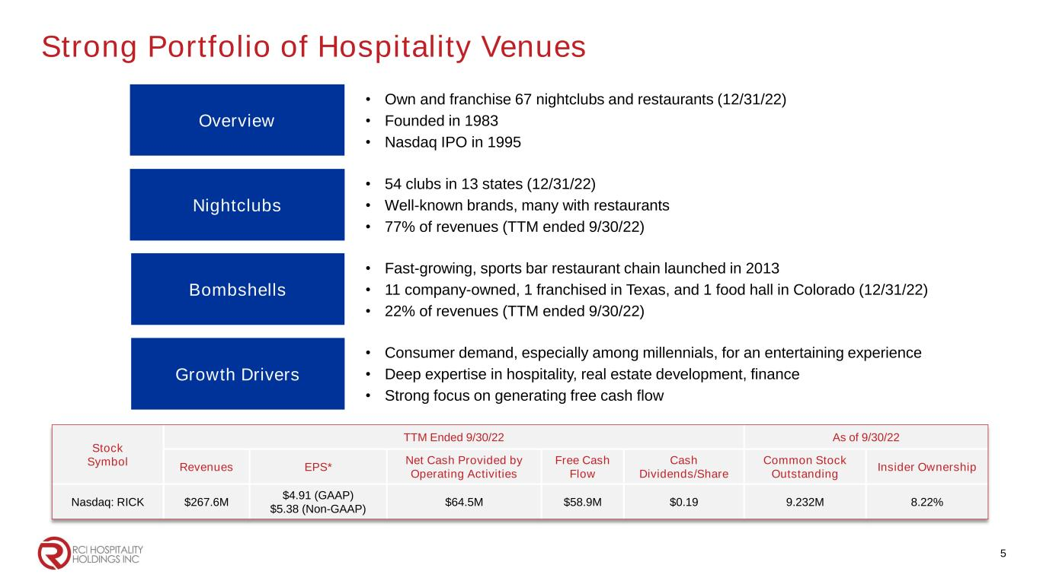
Strong Portfolio of Hospitality Venues Nightclubs • 54 clubs in 13 states (12/31/22) • Well-known brands, many with restaurants • 77% of revenues (TTM ended 9/30/22) Overview • Own and franchise 67 nightclubs and restaurants (12/31/22) • Founded in 1983 • Nasdaq IPO in 1995 Growth Drivers • Consumer demand, especially among millennials, for an entertaining experience • Deep expertise in hospitality, real estate development, finance • Strong focus on generating free cash flow Bombshells • Fast-growing, sports bar restaurant chain launched in 2013 • 11 company-owned, 1 franchised in Texas, and 1 food hall in Colorado (12/31/22) • 22% of revenues (TTM ended 9/30/22) Stock Symbol TTM Ended 9/30/22 As of 9/30/22 Revenues EPS* Net Cash Provided by Operating Activities Free Cash Flow Cash Dividends/Share Common Stock Outstanding Insider Ownership Nasdaq: RICK $267.6M $4.91 (GAAP) $5.38 (Non-GAAP) $64.5M $58.9M $0.19 9.232M 8.22% 5

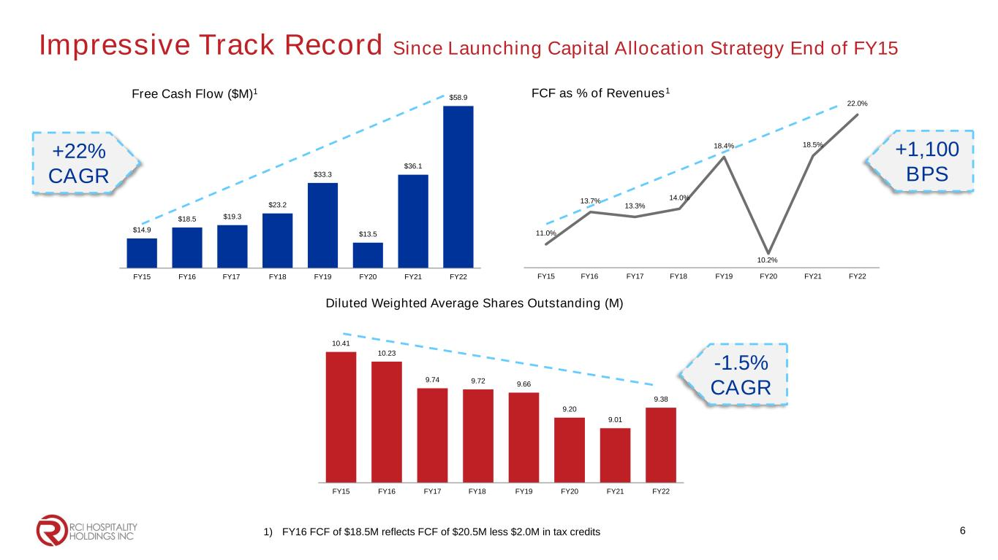
10.41 10.23 9.74 9.72 9.66 9.20 9.01 9.38 FY15 FY16 FY17 FY18 FY19 FY20 FY21 FY22 $14.9 $18.5 $19.3 $23.2 $33.3 $13.5 $36.1 $58.9 FY15 FY16 FY17 FY18 FY19 FY20 FY21 FY22 Free Cash Flow ($M)1 11.0% 13.7% 13.3% 14.0% 18.4% 10.2% 18.5% 22.0% FY15 FY16 FY17 FY18 FY19 FY20 FY21 FY22 FCF as % of Revenues1 Diluted Weighted Average Shares Outstanding (M) 1) FY16 FCF of $18.5M reflects FCF of $20.5M less $2.0M in tax credits 6 +22% CAGR +1,100 BPS -1.5% CAGR Impressive Track Record Since Launching Capital Allocation Strategy End of FY15

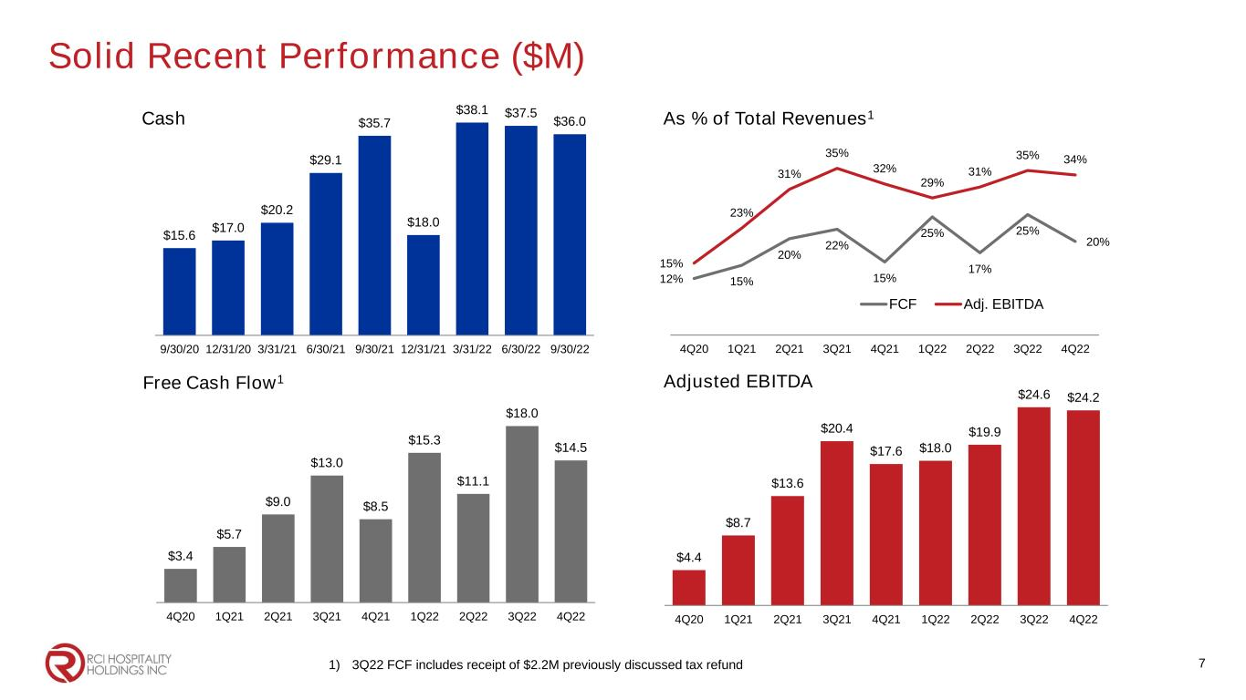
12% 15% 20% 22% 15% 25% 17% 25% 20% 15% 23% 31% 35% 32% 29% 31% 35% 34% 4Q20 1Q21 2Q21 3Q21 4Q21 1Q22 2Q22 3Q22 4Q22 FCF Adj. EBITDA $4.4 $8.7 $13.6 $20.4 $17.6 $18.0 $19.9 $24.6 $24.2 4Q20 1Q21 2Q21 3Q21 4Q21 1Q22 2Q22 3Q22 4Q22 $15.6 $17.0 $20.2 $29.1 $35.7 $18.0 $38.1 $37.5 $36.0 9/30/20 12/31/20 3/31/21 6/30/21 9/30/21 12/31/21 3/31/22 6/30/22 9/30/22 Cash As % of Total Revenues1 Adjusted EBITDA $3.4 $5.7 $9.0 $13.0 $8.5 $15.3 $11.1 $18.0 $14.5 4Q20 1Q21 2Q21 3Q21 4Q21 1Q22 2Q22 3Q22 4Q22 Free Cash Flow1 1) 3Q22 FCF includes receipt of $2.2M previously discussed tax refund 7 Solid Recent Performance ($M)

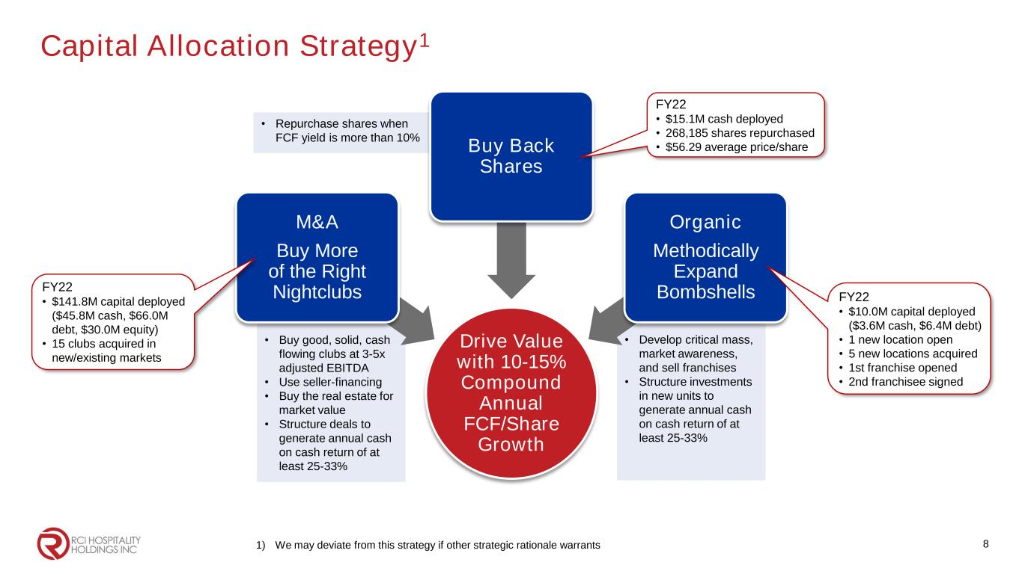
Capital Allocation Strategy1 1) We may deviate from this strategy if other strategic rationale warrants • Repurchase shares when FCF yield is more than 10% • Develop critical mass, market awareness, and sell franchises • Structure investments in new units to generate annual cash on cash return of at least 25-33% • Buy good, solid, cash flowing clubs at 3-5x adjusted EBITDA • Use seller-financing • Buy the real estate for market value • Structure deals to generate annual cash on cash return of at least 25-33% Drive Value with 10-15% Compound Annual FCF/Share Growth M&A Buy More of the Right Nightclubs Buy Back Shares Organic Methodically Expand Bombshells 8 FY22 • $15.1M cash deployed • 268,185 shares repurchased • $56.29 average price/share FY22 • $10.0M capital deployed ($3.6M cash, $6.4M debt) • 1 new location open • 5 new locations acquired • 1st franchise opened • 2nd franchisee signed FY22 • $141.8M capital deployed ($45.8M cash, $66.0M debt, $30.0M equity) • 15 clubs acquired in new/existing markets

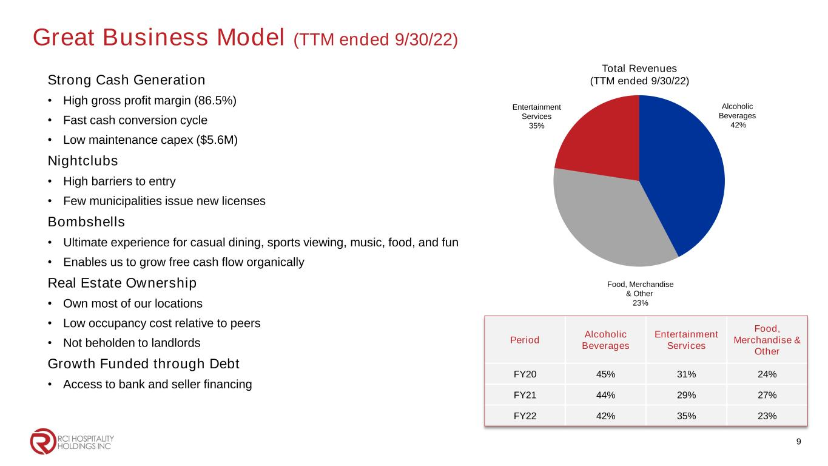
Great Business Model (TTM ended 9/30/22) Strong Cash Generation • High gross profit margin (86.5%) • Fast cash conversion cycle • Low maintenance capex ($5.6M) Nightclubs • High barriers to entry • Few municipalities issue new licenses Bombshells • Ultimate experience for casual dining, sports viewing, music, food, and fun • Enables us to grow free cash flow organically Real Estate Ownership • Own most of our locations • Low occupancy cost relative to peers • Not beholden to landlords Growth Funded through Debt • Access to bank and seller financing Total Revenues (TTM ended 9/30/22) Alcoholic Beverages 42% Entertainment Services 35% Food, Merchandise & Other 23% Period Alcoholic Beverages Entertainment Services Food, Merchandise & Other FY20 45% 31% 24% FY21 44% 29% 27% FY22 42% 35% 23% 9

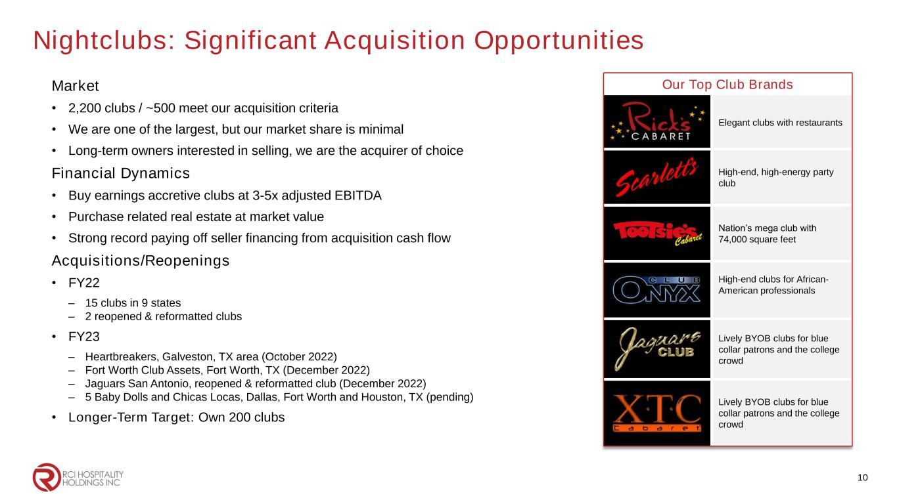
Nightclubs: Significant Acquisition Opportunities Market • 2,200 clubs / ~500 meet our acquisition criteria • We are one of the largest, but our market share is minimal • Long-term owners interested in selling, we are the acquirer of choice Financial Dynamics • Buy earnings accretive clubs at 3-5x adjusted EBITDA • Purchase related real estate at market value • Strong record paying off seller financing from acquisition cash flow Acquisitions/Reopenings • FY22 – 15 clubs in 9 states – 2 reopened & reformatted clubs • FY23 – Heartbreakers, Galveston, TX area (October 2022) – Fort Worth Club Assets, Fort Worth, TX (December 2022) – Jaguars San Antonio, reopened & reformatted club (December 2022) – 5 Baby Dolls and Chicas Locas, Dallas, Fort Worth and Houston, TX (pending) • Longer-Term Target: Own 200 clubs Our Top Club Brands Elegant clubs with restaurants High-end, high-energy party club Nation’s mega club with 74,000 square feet High-end clubs for African- American professionals Lively BYOB clubs for blue collar patrons and the college crowd Lively BYOB clubs for blue collar patrons and the college crowd 10

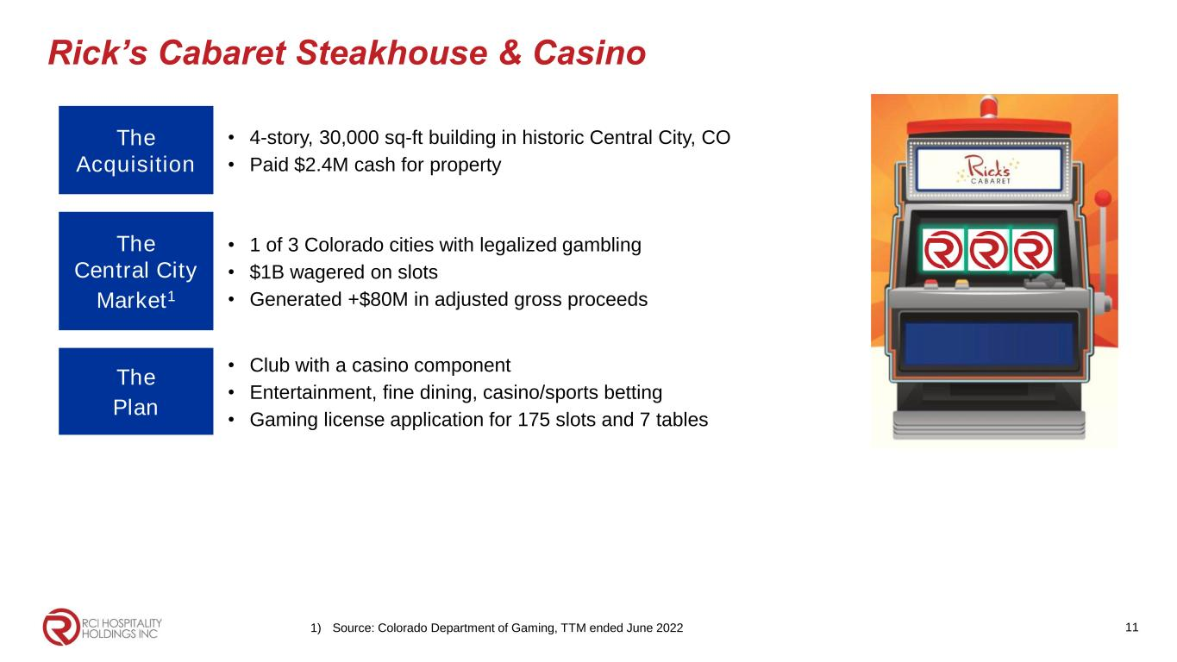
Rick’s Cabaret Steakhouse & Casino The Acquisition • 4-story, 30,000 sq-ft building in historic Central City, CO • Paid $2.4M cash for property The Central City Market1 • 1 of 3 Colorado cities with legalized gambling • $1B wagered on slots • Generated +$80M in adjusted gross proceeds The Plan • Club with a casino component • Entertainment, fine dining, casino/sports betting • Gaming license application for 175 slots and 7 tables 111) Source: Colorado Department of Gaming, TTM ended June 2022

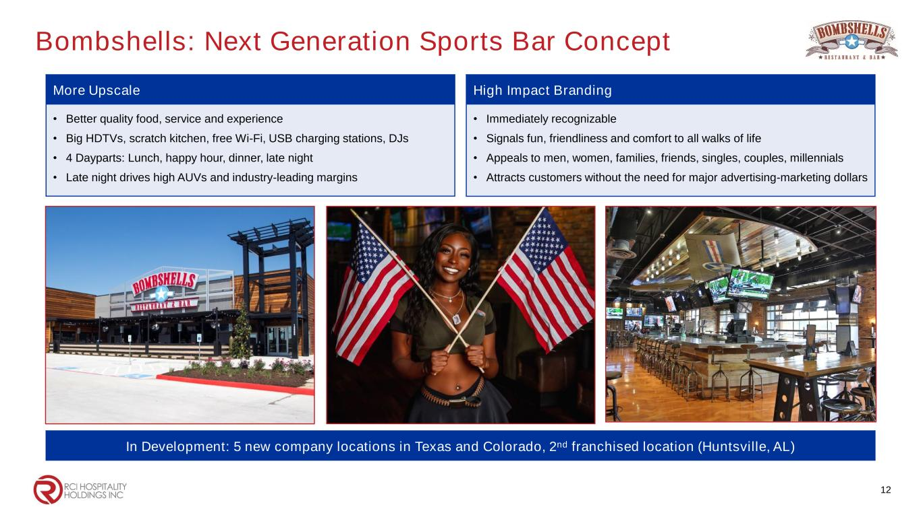
Bombshells: Next Generation Sports Bar Concept More Upscale • Better quality food, service and experience • Big HDTVs, scratch kitchen, free Wi-Fi, USB charging stations, DJs • 4 Dayparts: Lunch, happy hour, dinner, late night • Late night drives high AUVs and industry-leading margins 12 High Impact Branding • Immediately recognizable • Signals fun, friendliness and comfort to all walks of life • Appeals to men, women, families, friends, singles, couples, millennials • Attracts customers without the need for major advertising-marketing dollars In Development: 5 new company locations in Texas and Colorado, 2nd franchised location (Huntsville, AL)

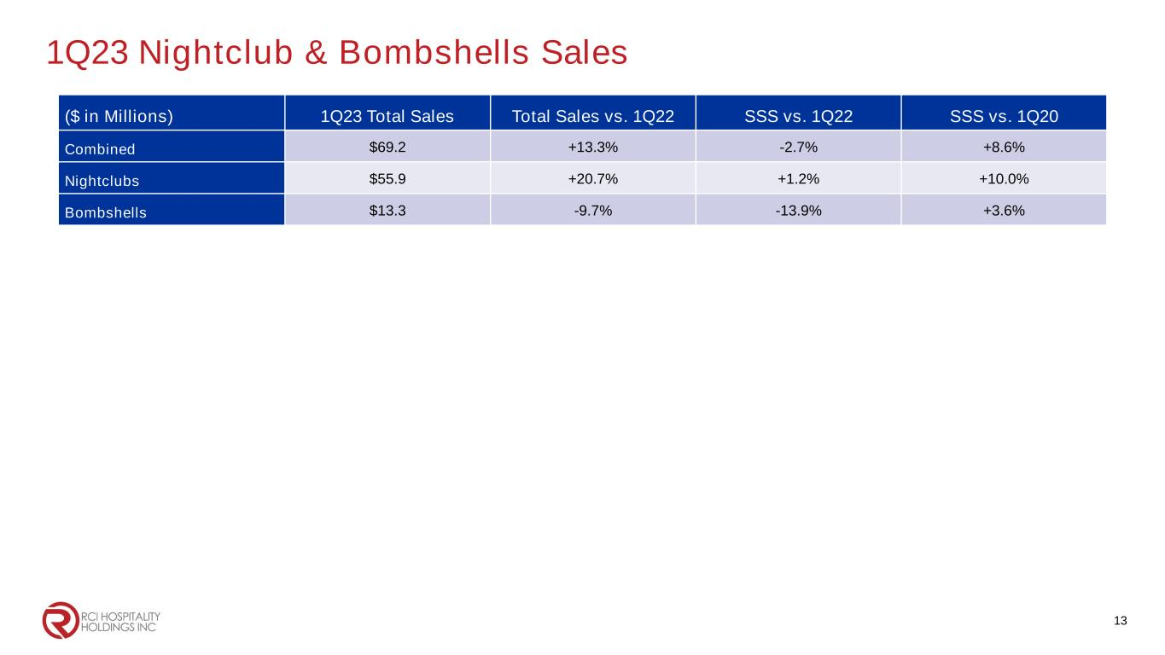
1Q23 Nightclub & Bombshells Sales 13 ($ in Millions) 1Q23 Total Sales Total Sales vs. 1Q22 SSS vs. 1Q22 SSS vs. 1Q20 Combined $69.2 +13.3% -2.7% +8.6% Nightclubs $55.9 +20.7% +1.2% +10.0% Bombshells $13.3 -9.7% -13.9% +3.6%

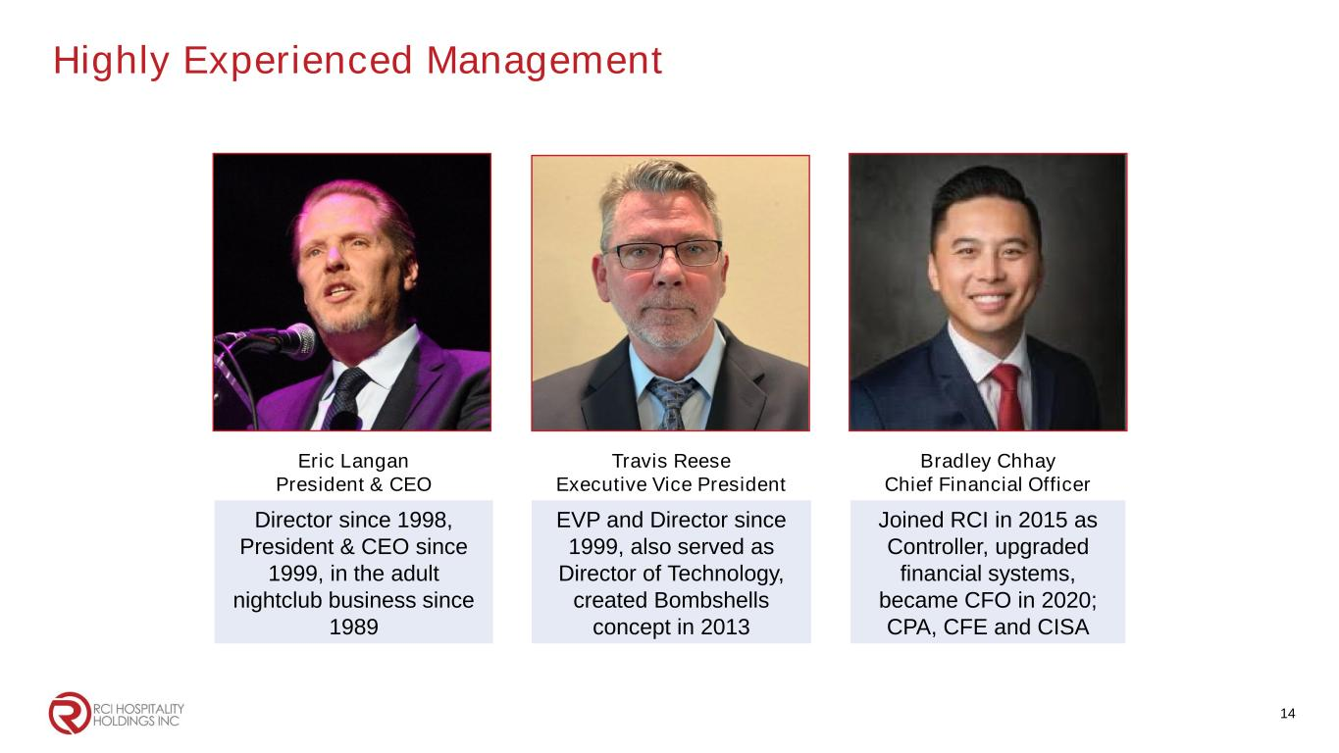
Highly Experienced Management 14 Eric Langan President & CEO Travis Reese Executive Vice President Bradley Chhay Chief Financial Officer Director since 1998, President & CEO since 1999, in the adult nightclub business since 1989 EVP and Director since 1999, also served as Director of Technology, created Bombshells concept in 2013 Joined RCI in 2015 as Controller, upgraded financial systems, became CFO in 2020; CPA, CFE and CISA


Corporate Office 10737 Cutten Road Houston, TX 77066 Phone: (281) 397-6730 Investor Relations Gary Fishman Steven Anreder Phone: (212) 532-3232 IR Website www.rcihospitality.com Nasdaq: RICK Contact Information 15

