United States
Securities and Exchange Commission
Washington, D.C. 20549
FORM 8-K
Current Report
Pursuant to Section 13 or 15(d) of
The Securities Exchange Act of 1934
Date of Report (Date of earliest event reported): August 9, 2022
RCI HOSPITALITY HOLDINGS, INC.
(Exact Name of Registrant as Specified in Its Charter)

Texas |  |  | 001-13992 |  |  | 76-0458229
(State or Other Jurisdiction  of Incorporation) |  |  | (Commission  File Number) |  |  | (IRS Employer  Identification No.)
10737 Cutten Road
Houston, Texas 77066
(Address of Principal Executive Offices, Including Zip Code)
(281) 397-6730
(Issuer’s Telephone Number, Including Area Code)
Check the appropriate box below if the Form 8-K filing is intended to simultaneously satisfy the filing obligation of the registrant under any of the following provisions:

o |  |  | Written communications pursuant to Rule 425 under the Securities Act (17 CFR 230.425)
o |  |  | Soliciting material pursuant to Rule 14a-12 under the Exchange Act (17 CFR 240.14a -12)
o |  |  | Pre-commencement communications pursuant to Rule 14d-2(b) under the Exchange Act (17 CFR 240.14d -2(b))
o |  |  | Pre-commencement communications pursuant to Rule 13e-4(c) under the Exchange Act (17 CFR 240.13e -4(c))
Securities registered pursuant to Section 12(b) of the Act:

Title of each class |  |  |  |  |  | Trading Symbol(s) |  |  |  |  |  | Name of each exchange on which registered
Common stock, $0.01 par value |  |  |  |  |  | RICK |  |  |  |  |  | The Nasdaq Global Market
Indicate by check mark whether the registrant is an emerging growth company as defined in Rule 405 of the Securities Act of 1933 (§230.405 of this chapter) or Rule 12b-2 of the Securities Exchange Act of 1934 (§240.12b-2 of this chapter).
Emerging growth company o
If an emerging growth company, indicate by check mark if the registrant has elected not to use the extended transition period for complying with any new or revised financial accounting standards provided pursuant to Section 13(a) of the Exchange Act. o

ITEM 2.02 RESULTS OF OPERATIONS AND FINANCIAL CONDITION.

On August 9, 2022, we issued a press release announcing results for the fiscal quarter ended June 30, 2022 and the filing of our quarterly report on Form 10-Q for that quarter. Also on August 9, 2022, we will hold a conference call to discuss these results and related matters. A copy of the press release is furnished as Exhibit 99.1 to this current report on Form 8-K.

This information shall not be deemed “filed” for purposes of Section 18 of the Securities Exchange Act of 1934, as amended (the “Exchange Act”), or incorporated by reference in any filing under the Securities Act of 1933, as amended, or the Exchange Act, except as shall be expressly set forth by specific reference in such a filing.

ITEM 9.01 FINANCIAL STATEMENTS AND EXHIBITS

(d) Exhibits

Exhibit Number |  |  |  |  |  | Description
99.1 |  |  |  |  |  | Press release of RCI Hospitality Holdings, Inc. dated August 9, 2022
104 |  |  |  |  |  | Cover Page Interactive Data File (embedded within the Inline XBRL document)
2

SIGNATURES
Pursuant to the requirements of the Securities Exchange Act of 1934, the registrant has duly caused this report to be signed on its behalf by the undersigned hereunto duly authorized.

 |  |  | RCI HOSPITALITY HOLDINGS, INC.
Date: August 9, 2022 |  |  | By: |  |  | /s/ Eric Langan
 |  |  |  |  |  | Eric Langan
 |  |  |  |  |  | President and Chief Executive Officer
3

Exhibit 99.1

RCI Reports 3Q22 Results: Total Revenues $70.7M, GAAP EPS $1.48, Non-GAAP EPS $1.60
Twitter Spaces Conference Call at 4:30 PM ET Today; Meet Management at 7 PM ET Tonight
HOUSTON—August 9, 2022—RCI Hospitality Holdings, Inc. (Nasdaq: RICK) today reported results and filed its Form 10-Q for the fiscal 2022 third quarter and nine months ended June 30, 2022.

Summary Financials |  |  | 3Q22 |  |  | Change YoY |  |  | 9M22 |  |  | Change YoY
Total Revenues |  |  | $70.7M |  |  | 22.2% |  |  | $196.2M |  |  | 39.9%
EPS |  |  | $1.48 |  |  | 8.0% |  |  | $3.76 |  |  | 20.9%
Non-GAAP EPS* |  |  | $1.60 |  |  | 18.0% |  |  | $3.89 |  |  | 55.5%
Net Cash from Operating Activities |  |  | $18.9M |  |  | 26.2% |  |  | $46.8M |  |  | 45.1%
Free Cash Flow* |  |  | $18.0M |  |  | 39.1% |  |  | $44.4M |  |  | 60.7%
Net Income Attributable to RCIHH Common Stockholders |  |  | $13.9M |  |  | 13.0% |  |  | $35.4M |  |  | 26.4%
Adjusted EBITDA* |  |  | $24.6M |  |  | 20.6% |  |  | $62.5M |  |  | 46.5%
Basic & Diluted Shares |  |  | 9.390M |  |  | 4.3% |  |  | 9.428M |  |  | 4.7%
* See “Non-GAAP Financial Measures” below.

Status FY22 Share Buybacks** |  |  | Repurchased Shares |  |  | Cash Used for Repurchase |  |  | Average Price Per Share
2Q22 |  |  | 45,643 |  |  | $2.85M |  |  | $62.33
3Q22 |  |  | 168,069 |  |  | $9.21M |  |  | $54.81
Current Quarter to Date as of 8/5/22 |  |  | 42,250 |  |  | $2.25M |  |  | $53.35
Total |  |  | 255,962 |  |  | $14.31M |  |  | $55.91
** No shares repurchased in 1Q22.
Eric Langan, President and CEO of RCI Hospitality Holdings, Inc., said: “RCI’s third quarter benefited from higher sales, a continued rebound in Nightclubs service revenues, and a sequential improvement in Bombshells. This resulted in particularly strong free cash flow and adjusted EBITDA. Net cash from operating activities and FCF were further enhanced by receipt of a $2.2 million previously discussed tax refund. We ended 3Q22 with $37.5 million in cash after utilizing more than $12 million for share buybacks for the nine months, the cash portion of the Playmates Club acquisition, and the down payment for the 13th company-owned Bombshells location. To date in 4Q22, we’ve continued our expansion by acquiring clubs in Odessa, TX and South Florida, and buying back more shares.”
Conference Call at 4:30 PM ET Today
Participants need to use Twitter Spaces on their mobile phones to ask questions during the Q&A
Twitter Spaces |  |  | Telephone |  |  | Webcast, Slides & Replay
Follow @RicksCEO, @ZeroTangoTango, @BradleyChhay, or @itsmarkmoran, and go to: https://twitter.com/i/spaces/1PlJQabdPNqJE |  |  | Toll Free 888-506-0062  International: 973-528-0011  Passcode: 353724 |  |  | https://www.webcaster4.com/Webcast/Page/2209/46217
Meet Management at 7:00 PM ET Tonight
Investors are invited to Meet Management at one of RCI’s top revenue generating clubs
Rick’s Cabaret New York, 50 W 33rd St, New York, NY 10001
RSVP your contact information to gary.fishman@anreder.com by 5:00 PM ET today
1

3Q22 Nightclubs Segment
Nightclubs generated revenues of $54.7 million at an operating margin of 41.1% (42.7% non-GAAP), resulting in segment operating income of $22.5 million ($23.3 million non-GAAP).
Revenues increased 33.3% compared to 3Q21. Acquisitions contributed $11.8 million of 3Q22 sales. Same-store sales grew 4.8%. High-margin service revenues expanded 50.8% year-over-year. The third quarter was the first period since 1Q20 not affected by COVID.
Compared to 2Q22, revenues increased 13.5%, non-GAAP operating margin improved 321 basis points, and non-GAAP segment income increased 22.7%, reflecting the continued rebound in Northern clubs and service revenues, and higher margins from acquisitions.
3Q22 Bombshells Segment
Bombshells generated revenues of $15.8 million at an operating margin of 19.4% (23.6% non-GAAP), resulting in segment operating income of $3.1 million ($3.7 million non-GAAP).
Revenues declined 1.8% compared to an unusually strong 3Q21, when Bombshells was one of the few bar and restaurant chains open in Texas due to the state of COVID at that time. Otherwise, Bombshells saw typical seasonal trends.
Compared to 2Q22, revenues increased 3.0%, non-GAAP operating margin improved 94 bps, and non-GAAP segment income increased 7.2%.
3Q22 Consolidated (Comparisons are to 3Q21 and % are of total revenues unless indicated otherwise)
Cost of goods sold (13.0% vs. 15.3%) reflected the increased sales mix of higher-margin service revenues (36.0% vs. 29.2%).
Salaries and wages (24.6% vs. 24.0%) and SG&A (27.7% vs. 25.4%) reflected new employees and increased expenses related to new and acquired locations.
Operating margin was 29.0% vs. 32.0% (31.2% vs. 31.8% non-GAAP).
Interest expense (4.3% vs. 3.9%) primarily reflected higher debt from FY22 acquisitions.
Income tax expense was $3.8 million compared to $4.0 million. The effective tax rate was 21.3% vs. 24.4%.
Weighted average shares outstanding increased 4.3% due to shares issued for clubs acquired in October 2021, partially offset by later share repurchases.
Debt was $188.0 million at 6/30/22 compared to $178.1 million at 3/31/22. The increase primarily reflected seller financing used in the May 2022 Playmates acquisition.
Note
As of the release of this report, we do not know the future extent and duration of the impact of COVID-19 on our businesses. We will continually monitor and evaluate our cash flow situation to decide whether any measures need to be instituted. All references to the “company,” “we,” “our,” and similar terms include RCI Hospitality Holdings, Inc., and its subsidiaries, unless the context indicates otherwise.
Non-GAAP Financial Measures
In addition to our financial information presented in accordance with GAAP, management uses certain non-GAAP financial measures, within the meaning of the SEC Regulation G, to clarify and enhance understanding of past performance and prospects for the future. Generally, a non-GAAP financial measure is a numerical measure of a company’s operating performance, financial position or cash flows that excludes or includes amounts that are included in or excluded from the most directly comparable measure calculated and presented in accordance with GAAP. We monitor non-GAAP financial measures because it describes the operating performance of the Company and helps management and investors gauge our ability to generate cash flow, excluding (or including) some items that management believes are not representative of the ongoing business operations of the Company, but are included in (or excluded from) the most directly comparable measures calculated and presented in accordance with GAAP. Relative to each of the non-GAAP financial measures, we further set forth our rationale as follows:
Non-GAAP Operating Income and Non-GAAP Operating Margin. We calculate non-GAAP operating income and non-GAAP operating margin by excluding the following items from income from operations and operating margin: (a) amortization of intangibles, (b) gains or losses on sale of businesses and assets, (c) gains or losses on insurance, (d) settlement of lawsuits, and (e) impairment of assets. We believe that excluding these items assists investors in evaluating period-over-period changes in our operating income and operating margin without the impact of items that are not a result of our day-to-day business and operations.
Non-GAAP Net Income and Non-GAAP Net Income per Diluted Share. We calculate non-GAAP net income and non-GAAP net income per diluted share by excluding or including certain items to net income attributable to RCIHH common stockholders and diluted earnings per share. Adjustment items are: (a) amortization of intangibles, (b) impairment of assets, (c) gains or losses on sale of businesses and assets, (d) gains or losses on insurance, (e) unrealized gains or losses on equity securities, (f) settlement of lawsuits, (g) gain on debt extinguishment, and (h) the income tax effect of the above-described adjustments. Included in the income tax effect of the above adjustments is the net effect of the non-GAAP provision for income taxes, calculated at 21.6% and 24.3% effective tax rate of the pre-tax non-GAAP income before taxes for the nine months ended June 30, 2022 and 2021, respectively, and the GAAP income tax expense (benefit). We
2

believe that excluding and including such items help management and investors better understand our operating activities.
Adjusted EBITDA. We calculate adjusted EBITDA by excluding the following items from net income attributable to RCIHH common stockholders: (a) depreciation and amortization, (b) income tax expense (benefit), (c) net interest expense, (d) gains or losses on sale of businesses and assets, (e) gains or losses on insurance, (f) unrealized gains or losses on equity securities, (g) impairment of assets, (h) settlement of lawsuits, and (i) gain on debt extinguishment. We believe that adjusting for such items helps management and investors better understand our operating activities. Adjusted EBITDA provides a core operational performance measurement that compares results without the need to adjust for federal, state and local taxes which have considerable variation between domestic jurisdictions. The results are, therefore, without consideration of financing alternatives of capital employed. We use adjusted EBITDA as one guideline to assess our unleveraged performance return on our investments. Adjusted EBITDA is also the target benchmark for our acquisitions of nightclubs.
Management also uses non-GAAP cash flow measures such as free cash flow. Free cash flow is derived from net cash provided by operating activities less maintenance capital expenditures. We use free cash flow as the baseline for the implementation of our capital allocation strategy.
About RCI Hospitality Holdings, Inc. (Nasdaq: RICK) www.rcihospitality.com
With more than 60 units, RCI Hospitality Holdings, Inc., through its subsidiaries, is the country’s leading company in adult nightclubs and sports bars/restaurants. Clubs in New York City, Chicago, Dallas-Fort Worth, Houston, Miami, Minneapolis, Denver, St. Louis, Charlotte, Pittsburgh, Raleigh, Louisville, and other markets operate under brand names such as Rick's Cabaret, XTC, Club Onyx, Vivid Cabaret, Jaguars Club, Tootsie’s Cabaret, Scarlett’s Cabaret, Diamond Cabaret, and PT’s Showclub. Sports bars/restaurants operate under the brand name Bombshells Restaurant & Bar.
Forward-Looking Statements
This press release may contain forward-looking statements that involve a number of risks and uncertainties that could cause the company’s actual results to differ materially from those indicated, including, but not limited to, the risks and uncertainties associated with (i) operating and managing an adult business, (ii) the business climates in cities where it operates, (iii) the success or lack thereof in launching and building the company’s businesses, (iv) cyber security, (v) conditions relevant to real estate transactions, (vi) the impact of the COVID-19 pandemic, and (vii) numerous other factors such as laws governing the operation of adult entertainment businesses, competition and dependence on key personnel. For more detailed discussion of such factors and certain risks and uncertainties, see RCI’s annual report on Form 10-K for the year ended September 30, 2021, as well as its other filings with the U.S. Securities and Exchange Commission. The company has no obligation to update or revise the forward-looking statements to reflect the occurrence of future events or circumstances.
Media & Investor Contacts
Gary Fishman and Steven Anreder at 212-532-3232 or gary.fishman@anreder.com and steven.anreder@anreder.com

3

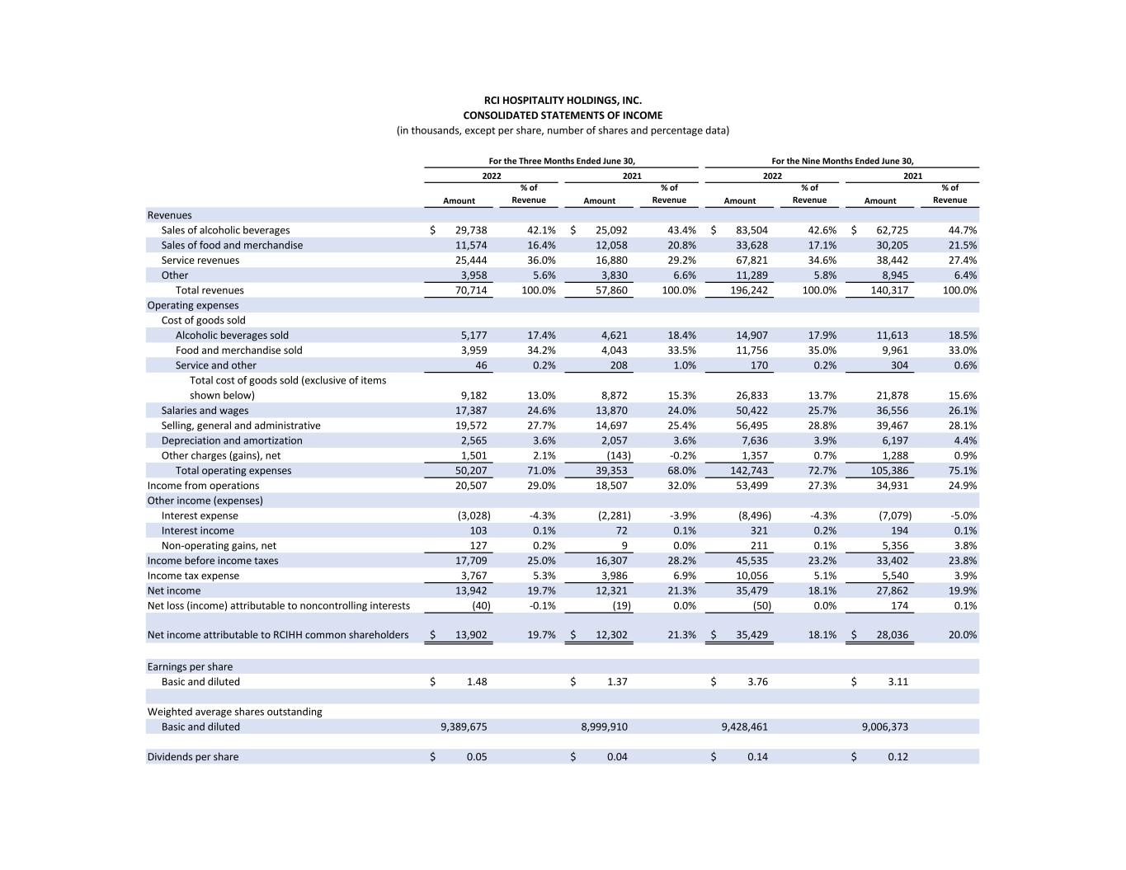
Amount % of Revenue Amount % of Revenue Amount % of Revenue Amount % of Revenue Revenues Sales of alcoholic beverages 29,738$ 42.1% 25,092$ 43.4% 83,504$ 42.6% 62,725$ 44.7% Sales of food and merchandise 11,574 16.4% 12,058 20.8% 33,628 17.1% 30,205 21.5% Service revenues 25,444 36.0% 16,880 29.2% 67,821 34.6% 38,442 27.4% Other 3,958 5.6% 3,830 6.6% 11,289 5.8% 8,945 6.4% Total revenues 70,714 100.0% 57,860 100.0% 196,242 100.0% 140,317 100.0% Operating expenses Cost of goods sold Alcoholic beverages sold 5,177 17.4% 4,621 18.4% 14,907 17.9% 11,613 18.5% Food and merchandise sold 3,959 34.2% 4,043 33.5% 11,756 35.0% 9,961 33.0% Service and other 46 0.2% 208 1.0% 170 0.2% 304 0.6% Total cost of goods sold (exclusive of items shown below) 9,182 13.0% 8,872 15.3% 26,833 13.7% 21,878 15.6% Salaries and wages 17,387 24.6% 13,870 24.0% 50,422 25.7% 36,556 26.1% Selling, general and administrative 19,572 27.7% 14,697 25.4% 56,495 28.8% 39,467 28.1% Depreciation and amortization 2,565 3.6% 2,057 3.6% 7,636 3.9% 6,197 4.4% Other charges (gains), net 1,501 2.1% (143) -0.2% 1,357 0.7% 1,288 0.9% Total operating expenses 50,207 71.0% 39,353 68.0% 142,743 72.7% 105,386 75.1% Income from operations 20,507 29.0% 18,507 32.0% 53,499 27.3% 34,931 24.9% Other income (expenses) Interest expense (3,028) -4.3% (2,281) -3.9% (8,496) -4.3% (7,079) -5.0% Interest income 103 0.1% 72 0.1% 321 0.2% 194 0.1% Non-operating gains, net 127 0.2% 9 0.0% 211 0.1% 5,356 3.8% Income before income taxes 17,709 25.0% 16,307 28.2% 45,535 23.2% 33,402 23.8% Income tax expense 3,767 5.3% 3,986 6.9% 10,056 5.1% 5,540 3.9% Net income 13,942 19.7% 12,321 21.3% 35,479 18.1% 27,862 19.9% (40) -0.1% (19) 0.0% (50) 0.0% 174 0.1% 13,902$ 19.7% 12,302$ 21.3% 35,429$ 18.1% 28,036$ 20.0% Earnings per share Basic and diluted 1.48$ 1.37$ 3.76$ 3.11$ Weighted average shares outstanding Basic and diluted 9,389,675 8,999,910 9,428,461 9,006,373 Dividends per share 0.05$ 0.04$ 0.14$ 0.12$ RCI HOSPITALITY HOLDINGS, INC. CONSOLIDATED STATEMENTS OF INCOME (in thousands, except per share, number of shares and percentage data) Net income attributable to RCIHH common shareholders Net loss (income) attributable to noncontrolling interests For the Nine Months Ended June 30, 2022 2021 For the Three Months Ended June 30, 2022 2021

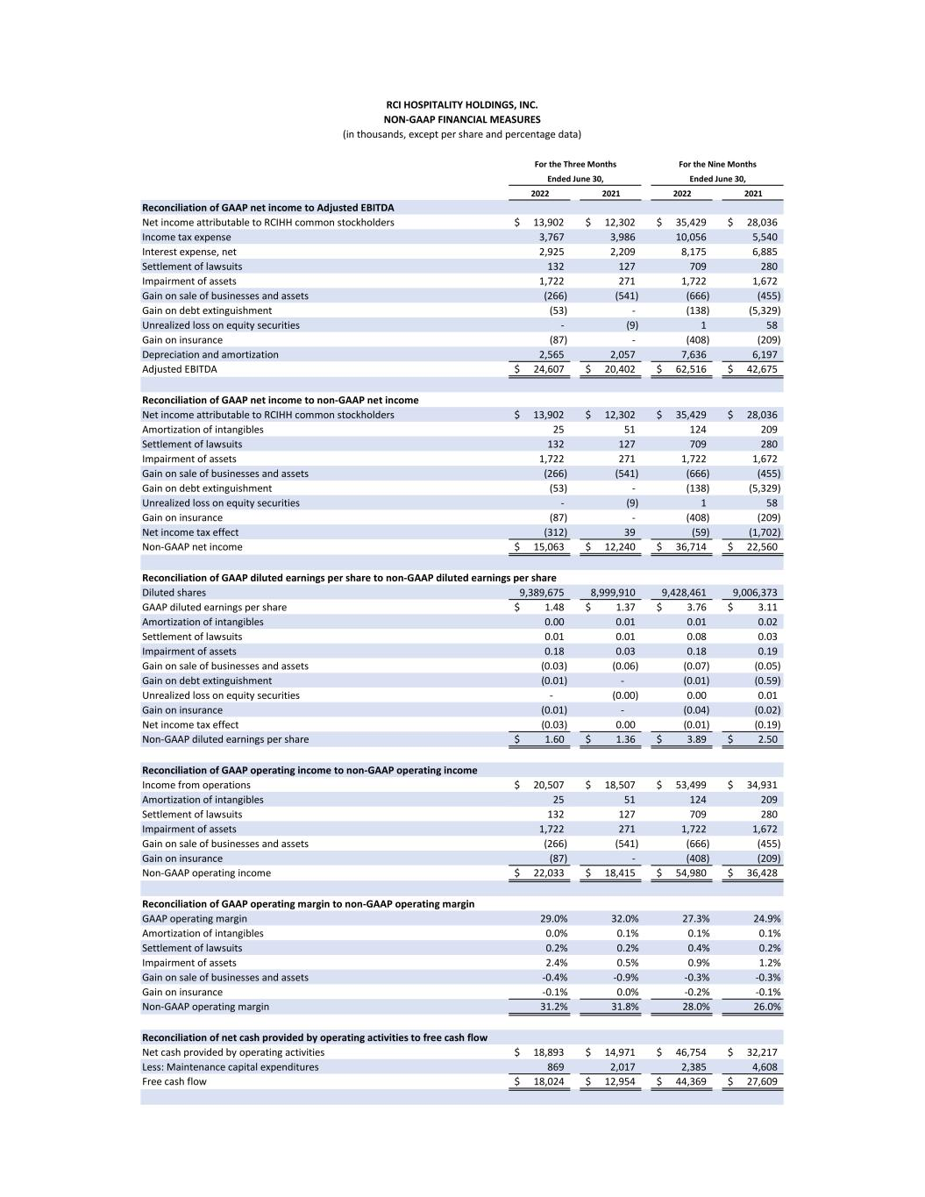
2022 2021 2022 2021 Reconciliation of GAAP net income to Adjusted EBITDA Net income attributable to RCIHH common stockholders 13,902$ 12,302$ 35,429$ 28,036$ Income tax expense 3,767 3,986 10,056 5,540 Interest expense, net 2,925 2,209 8,175 6,885 Settlement of lawsuits 132 127 709 280 Impairment of assets 1,722 271 1,722 1,672 Gain on sale of businesses and assets (266) (541) (666) (455) Gain on debt extinguishment (53) - (138) (5,329) Unrealized loss on equity securities - (9) 1 58 Gain on insurance (87) - (408) (209) Depreciation and amortization 2,565 2,057 7,636 6,197 Adjusted EBITDA 24,607$ 20,402$ 62,516$ 42,675$ Reconciliation of GAAP net income to non-GAAP net income Net income attributable to RCIHH common stockholders 13,902$ 12,302$ 35,429$ 28,036$ Amortization of intangibles 25 51 124 209 Settlement of lawsuits 132 127 709 280 Impairment of assets 1,722 271 1,722 1,672 Gain on sale of businesses and assets (266) (541) (666) (455) Gain on debt extinguishment (53) - (138) (5,329) Unrealized loss on equity securities - (9) 1 58 Gain on insurance (87) - (408) (209) Net income tax effect (312) 39 (59) (1,702) Non-GAAP net income 15,063$ 12,240$ 36,714$ 22,560$ Reconciliation of GAAP diluted earnings per share to non-GAAP diluted earnings per share Diluted shares 9,389,675 8,999,910 9,428,461 9,006,373 GAAP diluted earnings per share 1.48$ 1.37$ 3.76$ 3.11$ Amortization of intangibles 0.00 0.01 0.01 0.02 Settlement of lawsuits 0.01 0.01 0.08 0.03 Impairment of assets 0.18 0.03 0.18 0.19 Gain on sale of businesses and assets (0.03) (0.06) (0.07) (0.05) Gain on debt extinguishment (0.01) - (0.01) (0.59) Unrealized loss on equity securities - (0.00) 0.00 0.01 Gain on insurance (0.01) - (0.04) (0.02) Net income tax effect (0.03) 0.00 (0.01) (0.19) Non-GAAP diluted earnings per share 1.60$ 1.36$ 3.89$ 2.50$ Reconciliation of GAAP operating income to non-GAAP operating income Income from operations 20,507$ 18,507$ 53,499$ 34,931$ Amortization of intangibles 25 51 124 209 Settlement of lawsuits 132 127 709 280 Impairment of assets 1,722 271 1,722 1,672 Gain on sale of businesses and assets (266) (541) (666) (455) Gain on insurance (87) - (408) (209) Non-GAAP operating income 22,033$ 18,415$ 54,980$ 36,428$ Reconciliation of GAAP operating margin to non-GAAP operating margin GAAP operating margin 29.0% 32.0% 27.3% 24.9% Amortization of intangibles 0.0% 0.1% 0.1% 0.1% Settlement of lawsuits 0.2% 0.2% 0.4% 0.2% Impairment of assets 2.4% 0.5% 0.9% 1.2% Gain on sale of businesses and assets -0.4% -0.9% -0.3% -0.3% Gain on insurance -0.1% 0.0% -0.2% -0.1% Non-GAAP operating margin 31.2% 31.8% 28.0% 26.0% Reconciliation of net cash provided by operating activities to free cash flow Net cash provided by operating activities 18,893$ 14,971$ 46,754$ 32,217$ Less: Maintenance capital expenditures 869 2,017 2,385 4,608 Free cash flow 18,024$ 12,954$ 44,369$ 27,609$ RCI HOSPITALITY HOLDINGS, INC. NON-GAAP FINANCIAL MEASURES (in thousands, except per share and percentage data) For the Nine Months Ended June 30, For the Three Months Ended June 30,

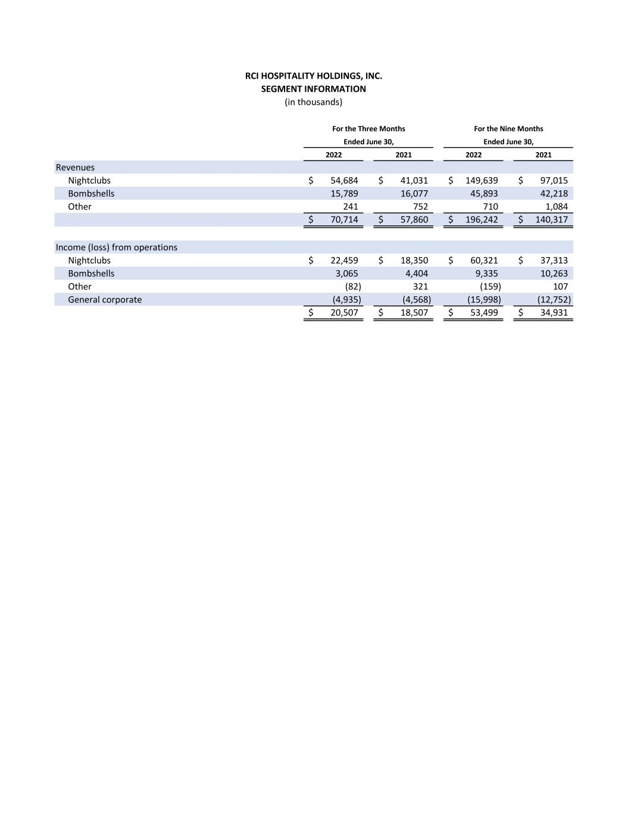
2022 2021 2022 2021 Revenues Nightclubs 54,684$ 41,031$ 149,639$ 97,015$ Bombshells 15,789 16,077 45,893 42,218 Other 241 752 710 1,084 70,714$ 57,860$ 196,242$ 140,317$ Income (loss) from operations Nightclubs 22,459$ 18,350$ 60,321$ 37,313$ Bombshells 3,065 4,404 9,335 10,263 Other (82) 321 (159) 107 General corporate (4,935) (4,568) (15,998) (12,752) 20,507$ 18,507$ 53,499$ 34,931$ RCI HOSPITALITY HOLDINGS, INC. SEGMENT INFORMATION (in thousands) For the Nine Months Ended June 30, For the Three Months Ended June 30,

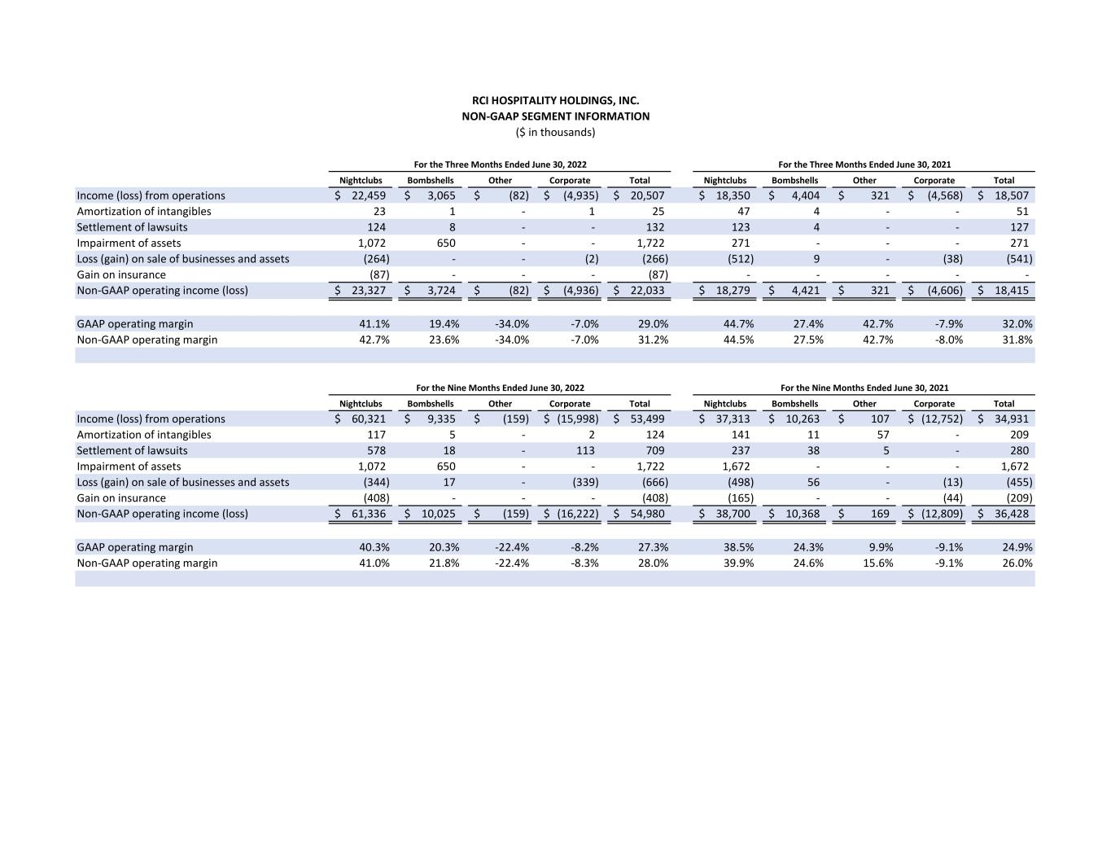
Nightclubs Bombshells Other Corporate Total Nightclubs Bombshells Other Corporate Total Income (loss) from operations 22,459$ 3,065$ (82)$ (4,935)$ 20,507$ 18,350$ 4,404$ 321$ (4,568)$ 18,507$ Amortization of intangibles 23 1 - 1 25 47 4 - - 51 Settlement of lawsuits 124 8 - - 132 123 4 - - 127 Impairment of assets 1,072 650 - - 1,722 271 - - - 271 Loss (gain) on sale of businesses and assets (264) - - (2) (266) (512) 9 - (38) (541) Gain on insurance (87) - - - (87) - - - - - Non-GAAP operating income (loss) 23,327$ 3,724$ (82)$ (4,936)$ 22,033$ 18,279$ 4,421$ 321$ (4,606)$ 18,415$ GAAP operating margin 41.1% 19.4% -34.0% -7.0% 29.0% 44.7% 27.4% 42.7% -7.9% 32.0% Non-GAAP operating margin 42.7% 23.6% -34.0% -7.0% 31.2% 44.5% 27.5% 42.7% -8.0% 31.8% Nightclubs Bombshells Other Corporate Total Nightclubs Bombshells Other Corporate Total Income (loss) from operations 60,321$ 9,335$ (159)$ (15,998)$ 53,499$ 37,313$ 10,263$ 107$ (12,752)$ 34,931$ Amortization of intangibles 117 5 - 2 124 141 11 57 - 209 Settlement of lawsuits 578 18 - 113 709 237 38 5 - 280 Impairment of assets 1,072 650 - - 1,722 1,672 - - - 1,672 Loss (gain) on sale of businesses and assets (344) 17 - (339) (666) (498) 56 - (13) (455) Gain on insurance (408) - - - (408) (165) - - (44) (209) Non-GAAP operating income (loss) 61,336$ 10,025$ (159)$ (16,222)$ 54,980$ 38,700$ 10,368$ 169$ (12,809)$ 36,428$ GAAP operating margin 40.3% 20.3% -22.4% -8.2% 27.3% 38.5% 24.3% 9.9% -9.1% 24.9% Non-GAAP operating margin 41.0% 21.8% -22.4% -8.3% 28.0% 39.9% 24.6% 15.6% -9.1% 26.0% For the Nine Months Ended June 30, 2022 For the Nine Months Ended June 30, 2021 ($ in thousands) NON-GAAP SEGMENT INFORMATION RCI HOSPITALITY HOLDINGS, INC. For the Three Months Ended June 30, 2022 For the Three Months Ended June 30, 2021

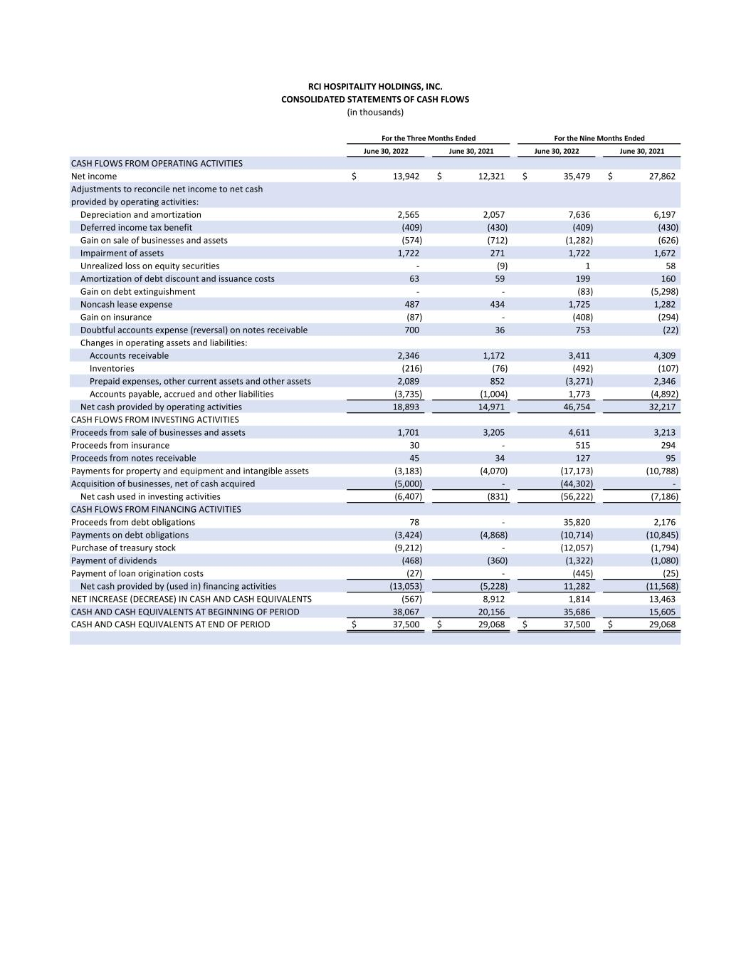
June 30, 2022 June 30, 2021 June 30, 2022 June 30, 2021 CASH FLOWS FROM OPERATING ACTIVITIES Net income 13,942$ 12,321$ 35,479$ 27,862$ Adjustments to reconcile net income to net cash provided by operating activities: Depreciation and amortization 2,565 2,057 7,636 6,197 Deferred income tax benefit (409) (430) (409) (430) Gain on sale of businesses and assets (574) (712) (1,282) (626) Impairment of assets 1,722 271 1,722 1,672 Unrealized loss on equity securities - (9) 1 58 Amortization of debt discount and issuance costs 63 59 199 160 Gain on debt extinguishment - - (83) (5,298) Noncash lease expense 487 434 1,725 1,282 Gain on insurance (87) - (408) (294) Doubtful accounts expense (reversal) on notes receivable 700 36 753 (22) Changes in operating assets and liabilities: Accounts receivable 2,346 1,172 3,411 4,309 Inventories (216) (76) (492) (107) Prepaid expenses, other current assets and other assets 2,089 852 (3,271) 2,346 Accounts payable, accrued and other liabilities (3,735) (1,004) 1,773 (4,892) Net cash provided by operating activities 18,893 14,971 46,754 32,217 CASH FLOWS FROM INVESTING ACTIVITIES Proceeds from sale of businesses and assets 1,701 3,205 4,611 3,213 Proceeds from insurance 30 - 515 294 Proceeds from notes receivable 45 34 127 95 Payments for property and equipment and intangible assets (3,183) (4,070) (17,173) (10,788) Acquisition of businesses, net of cash acquired (5,000) - (44,302) - Net cash used in investing activities (6,407) (831) (56,222) (7,186) CASH FLOWS FROM FINANCING ACTIVITIES Proceeds from debt obligations 78 - 35,820 2,176 Payments on debt obligations (3,424) (4,868) (10,714) (10,845) Purchase of treasury stock (9,212) - (12,057) (1,794) Payment of dividends (468) (360) (1,322) (1,080) Payment of loan origination costs (27) - (445) (25) Net cash provided by (used in) financing activities (13,053) (5,228) 11,282 (11,568) NET INCREASE (DECREASE) IN CASH AND CASH EQUIVALENTS (567) 8,912 1,814 13,463 CASH AND CASH EQUIVALENTS AT BEGINNING OF PERIOD 38,067 20,156 35,686 15,605 CASH AND CASH EQUIVALENTS AT END OF PERIOD 37,500$ 29,068$ 37,500$ 29,068$ RCI HOSPITALITY HOLDINGS, INC. CONSOLIDATED STATEMENTS OF CASH FLOWS (in thousands) For the Nine Months EndedFor the Three Months Ended

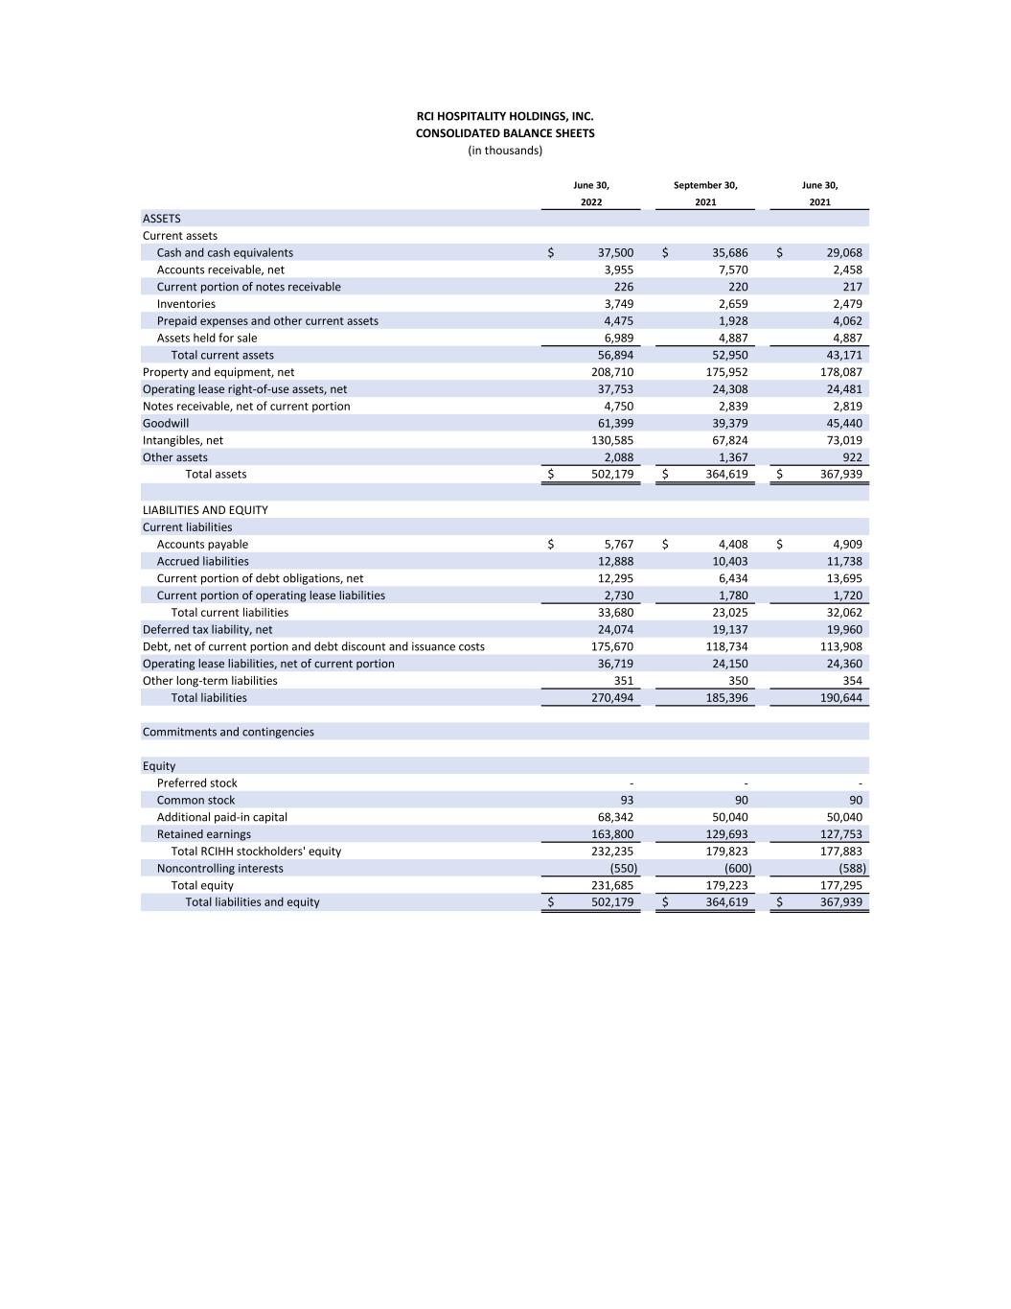
June 30, September 30, June 30, 2022 2021 2021 ASSETS Current assets Cash and cash equivalents 37,500$ 35,686$ 29,068$ Accounts receivable, net 3,955 7,570 2,458 Current portion of notes receivable 226 220 217 Inventories 3,749 2,659 2,479 Prepaid expenses and other current assets 4,475 1,928 4,062 Assets held for sale 6,989 4,887 4,887 Total current assets 56,894 52,950 43,171 Property and equipment, net 208,710 175,952 178,087 Operating lease right-of-use assets, net 37,753 24,308 24,481 Notes receivable, net of current portion 4,750 2,839 2,819 Goodwill 61,399 39,379 45,440 Intangibles, net 130,585 67,824 73,019 Other assets 2,088 1,367 922 Total assets 502,179$ 364,619$ 367,939$ LIABILITIES AND EQUITY Current liabilities Accounts payable 5,767$ 4,408$ 4,909$ Accrued liabilities 12,888 10,403 11,738 Current portion of debt obligations, net 12,295 6,434 13,695 Current portion of operating lease liabilities 2,730 1,780 1,720 Total current liabilities 33,680 23,025 32,062 Deferred tax liability, net 24,074 19,137 19,960 Debt, net of current portion and debt discount and issuance costs 175,670 118,734 113,908 Operating lease liabilities, net of current portion 36,719 24,150 24,360 Other long-term liabilities 351 350 354 Total liabilities 270,494 185,396 190,644 Commitments and contingencies Equity Preferred stock - - - Common stock 93 90 90 Additional paid-in capital 68,342 50,040 50,040 Retained earnings 163,800 129,693 127,753 Total RCIHH stockholders' equity 232,235 179,823 177,883 Noncontrolling interests (550) (600) (588) Total equity 231,685 179,223 177,295 Total liabilities and equity 502,179$ 364,619$ 367,939$ RCI HOSPITALITY HOLDINGS, INC. CONSOLIDATED BALANCE SHEETS (in thousands)

