United States
Securities and Exchange Commission
Washington, D.C. 20549

FORM 8-K

Current Report

Pursuant to Section 13 or 15(d) of

The Securities Exchange Act of 1934

Date of Report (Date of earliest event reported): January 12, 2021

RCI HOSPITALITY HOLDINGS, INC.
(Exact Name of Registrant as Specified in Its Charter)

Texas |  | 001-13992 |  | 76-0458229
(State or Other Jurisdiction  of Incorporation) |  | (Commission  File Number) |  | (IRS Employer  Identification No.)

10737 Cutten Road
Houston, Texas 77066
(Address of Principal Executive Offices, Including Zip Code)

(281) 397-6730
(Issuer’s Telephone Number, Including Area Code)

Check the appropriate box below if the Form 8-K filing is intended to simultaneously satisfy the filing obligation of the registrant under any of the following provisions:

☐ | Written communications pursuant to Rule 425 under the Securities Act (17 CFR 230.425)
☐ | Soliciting material pursuant to Rule 14a-12 under the Exchange Act (17 CFR 240.14a -12)
☐ | Pre-commencement communications pursuant to Rule 14d-2(b) under the Exchange Act (17 CFR 240.14d -2(b))
☐ | Pre-commencement communications pursuant to Rule 13e-4(c) under the Exchange Act (17 CFR 240.13e -4(c))

Securities registered pursuant to Section 12(b) of the Act:

Title of each class |  | Trading Symbol(s) |  | Name of each exchange on which registered
Common stock, $0.01 par value |  | RICK |  | The Nasdaq Global Market

Indicate by check mark whether the registrant is an emerging growth company as defined in Rule 405 of the Securities Act of 1933 (§230.405 of this chapter) or Rule 12b-2 of the Securities Exchange Act of 1934 (§240.12b-2 of this chapter).

Emerging growth company ☐

If an emerging growth company, indicate by check mark if the registrant has elected not to use the extended transition period for complying with any new or revised financial accounting standards provided pursuant to Section 13(a) of the Exchange Act. ☐

ITEM 2.02 RESULTS OF OPERATIONS AND FINANCIAL CONDITION.

On January 12, 2021, we issued a press release announcing sales at nightclubs and restaurants for the first fiscal quarter ended December 31, 2020. A copy of the press release is furnished as Exhibit 99.1 to this current report on Form 8-K.

This information shall not be deemed “filed” for purposes of Section 18 of the Securities Exchange Act of 1934, as amended (the “Exchange Act”), or incorporated by reference in any filing under the Securities Act of 1933, as amended, or the Exchange Act, except as shall be expressly set forth by specific reference in such a filing.

ITEM 9.01 FINANCIAL STATEMENTS AND EXHIBITS

(d) Exhibits

Exhibit Number |  | Description
99.1 |  | Press release of RCI Hospitality Holdings, Inc. dated January 12, 2021

2

SIGNATURES

Pursuant to the requirements of the Securities Exchange Act of 1934, the registrant has duly caused this report to be signed on its behalf by the undersigned hereunto duly authorized.

 |  | RCI HOSPITALITY HOLDINGS, INC.
Date: | January 12, 2021 | By: | /s/ Eric Langan
 |  |  | Eric Langan
 |  |  | President and Chief Executive Officer

3

Exhibit 99.1



RCI Reports 1Q21 Club & Restaurant Sales, Reflecting Continued Rebound

HOUSTON—January 12, 2021—RCI Hospitality Holdings, Inc. (Nasdaq: RICK) today reported sales for its Nightclubs and Bombshells restaurants for the fiscal 2021 first quarter ended December 31, 2020. Results reflect a continued rebound from April 2020 when all locations were closed due to the COVID-19 pandemic.

1Q21 vs. 1Q20

● | Total club and restaurant sales: $37.8 million compared to $47.8 million (-20.9%)
● | Consolidated same-store sales: $30.4 million compared to $30.9 million (-1.5%)
● | Nightclubs total sales: $24.8 million compared to $37.4 million (-33.7%)
● | Nightclubs same-store sales: $20.7 million compared to $22.2 million (-6.8%)
● | Bombshells total sales: $13.0 million compared to $10.3 million (+25.4%)
● | Bombshells same-store sales: $9.8 million compared to $8.7 million (+12.0%)

Open Status

● | During 1Q21, 24 clubs were open during the full quarter and 26 by period end, and all 10 Bombshells were open | 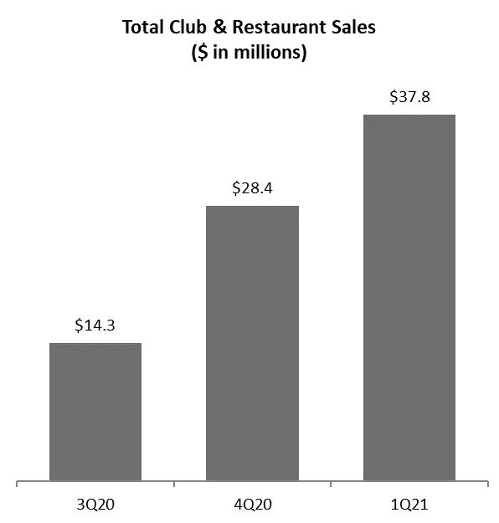
● | During 1Q20, 38 clubs were open, and the ninth Bombshells opened October 2019
● | As of yesterday, 39 of 48 locations were open (10 Bombshells and 29 Clubs)
● | All locations continue to limit occupancy in accordance with coronavirus safety plans, and not all clubs are operating at full schedules, in line with local government restrictions

CEO Comment

Eric Langan, President & CEO, said, “We are pleased to continue to have strong results through the COVID pandemic. We’ll still have to manage the ups and downs of COVID restrictions for at least the next two quarters, but are hopeful more locations will reopen and stay open as vaccine distribution ramps up.

“First quarter club sales reflected more locations open on a more consistent basis versus last quarter. Most clubs that were open continued to rebuild customer traffic. This was partially offset by the need to keep locations in New York City, Illinois, Minneapolis, and some other markets closed due to COVID restrictions.

“Bombshells continued its momentum with record first quarter sales, the signing of our first franchise agreement, and more interest from potential franchisees.

“We greatly appreciate the loyalty of our customers. Special thanks to our team members for making everything possible. We require all customers to follow COVID-related guidelines in our establishments so we can stay safe, remain open, serve our guests, and keep our team members working. We anticipate filing our 10-Q and reporting full 1Q21 financial results by February 9.”

1

Notes

● | Sales do not include non-core operations and are preliminary and subject to final closing.
● | Due to COVID-related closures, not all locations were open enough days, among other factors, to be included in 1Q21 same-store sales calculations.
● | All references to “RCI Hospitality Holdings, Inc.,” “company,” “we,” “our,” and similar terms refer to RCI and/or its subsidiaries, unless the context indicates otherwise.

Forward-Looking Statements

This press release may contain forward-looking statements that involve a number of risks and uncertainties that could cause the company’s actual results to differ materially from those indicated in this press release, including, but not limited to, the risks and uncertainties associated with (i) operating and managing an adult business, (ii) the business climates in cities where it operates, (iii) the success or lack thereof in launching and building the company’s businesses, (iv) cyber security, (v) conditions relevant to real estate transactions, (vi) the impact of the COVID-19 pandemic, and (vii) numerous other factors such as laws governing the operation of adult entertainment businesses, competition and dependence on key personnel. For more detailed discussion of such factors and certain risks and uncertainties, see RCI’s annual report on Form 10-K for the year ended September 30, 2020 as well as its other filings with the U.S. Securities and Exchange Commission. The company has no obligation to update or revise the forward-looking statements to reflect the occurrence of future events or circumstances.

Media & Investor Contacts

Gary Fishman and Steven Anreder at 212-532-3232 or gary.fishman@anreder.com and steven.anreder@anreder.com

2

