United States
Securities and Exchange Commission
Washington, D.C. 20549

FORM 8-K

Current Report

Pursuant to Section 13 or 15(d) of

The Securities Exchange Act of 1934

Date of Report (Date of earliest event reported): July 9, 2019

RCI HOSPITALITY HOLDINGS, INC.
(Exact Name of Registrant as Specified in Its Charter)

Texas |  | 001-13992 |  | 76-0458229
(State or Other Jurisdiction  of Incorporation) |  | (Commission  File Number) |  | (IRS Employer  Identification No.)

10737 Cutten Road
Houston, Texas 77066
(Address of Principal Executive Offices, Including Zip Code)

(281) 397-6730
(Issuer’s Telephone Number, Including Area Code)

Check the appropriate box below if the Form 8-K filing is intended to simultaneously satisfy the filing obligation of the registrant under any of the following provisions:

[ ] | Written communications pursuant to Rule 425 under the Securities Act (17 CFR 230.425)
[ ] | Soliciting material pursuant to Rule 14a-12 under the Exchange Act (17 CFR 240.14a -12)
[ ] | Pre-commencement communications pursuant to Rule 14d-2(b) under the Exchange Act (17 CFR 240.14d -2(b))
[ ] | Pre-commencement communications pursuant to Rule 13e-4(c) under the Exchange Act (17 CFR 240.13e -4(c))

Securities registered pursuant to Section 12(b) of the Act:

Title of each class |  | Trading Symbol(s) |  | Name of each exchange on which  registered
Common stock, $0.01 par value |  | RICK |  | The Nasdaq Global Market

Indicate by check mark whether the registrant is an emerging growth company as defined in Rule 405 of the Securities Act of 1933 (§230.405 of this chapter) or Rule 12b-2 of the Securities Exchange Act of 1934 (§240.12b-2 of this chapter).

Emerging growth company [ ]

If an emerging growth company, indicate by check mark if the registrant has elected not to use the extended transition period for complying with any new or revised financial accounting standards provided pursuant to Section 13(a) of the Exchange Act. [ ]

ITEM 2.02 RESULTS OF OPERATIONS AND FINANCIAL CONDITION.

On July 9, 2019, we issued a press release announcing total and same-store sales at nightclubs and restaurants for the third fiscal quarter ended June 30, 2019. A copy of the press release is furnished as Exhibit 99.1 to this Current Report on Form 8-K.

This information shall not be deemed “filed” for purposes of Section 18 of the Securities Exchange Act of 1934, as amended (the “Exchange Act”), or incorporated by reference in any filing under the Securities Act of 1933, as amended, or the Exchange Act, except as shall be expressly set forth by specific reference in such a filing.

ITEM 9.01 FINANCIAL STATEMENTS AND EXHIBITS

(d) Exhibits

Exhibit Number |  | Description
99.1 |  | Press release of RCI Hospitality Holdings, Inc. dated July 9, 2019

SIGNATURES

Pursuant to the requirements of the Securities Exchange Act of 1934, the registrant has duly caused this report on Form 8-K to be signed on its behalf by the undersigned hereunto duly authorized.

 | RCI HOSPITALITY HOLDINGS, INC .
Date: July 9, 2019 | By: | /s/ Eric Langan
 |  | Eric Langan
 |  | President and Chief Executive Officer



RCI Reports 3Q19 Club & Restaurant Total Sales Up 9.9%

HOUSTON—July 9, 2019—RCI Hospitality Holdings, Inc. (Nasdaq: RICK) today announced total and same-store sales for its Nightclubs and Bombshells restaurants for the Fiscal 2019 third quarter ended June 30, 2019.

3Q19 vs. 3Q18

● | Total club and restaurant sales: $46.2 million compared to $42.1 million – up 9.9%
● | Consolidated same-store sales: $39.1 million compared to $39.6 million – down 1.4%
● | Nightclubs total sales: $37.5 million compared to $34.9 million (38 units in both periods) – up 7.2%
● | Nightclubs same-store sales: $34.2 million compared to $34.1 million – up 0.1%
● | Bombshells total sales: $8.8 million compared to $7.1 million (8 units vs. 6) – up 23.0%
● | Bombshells same-store sales: $4.9 million compared to $5.5 million – down 10.6%

Effective 3Q19, Bombshells same-store sales now include locations open at least 18 months versus 12 months so the calculation is not affected by the “honeymoon” period experienced in the first six months of a new unit when revenues are higher compared to more normalized subsequent rates. This change in methodology is based on more than six years of experience successfully building out the restaurant chain and is in keeping with industry practices for casual dining chains owned by a number of larger publicly traded companies. Nightclubs are not affected by this change as nearly all have been acquired and had prior operating histories.

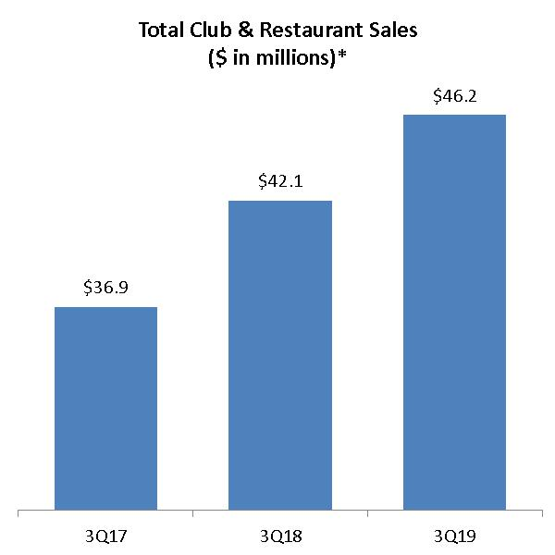 | 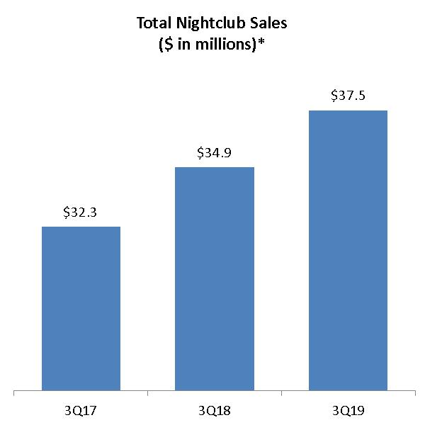 | 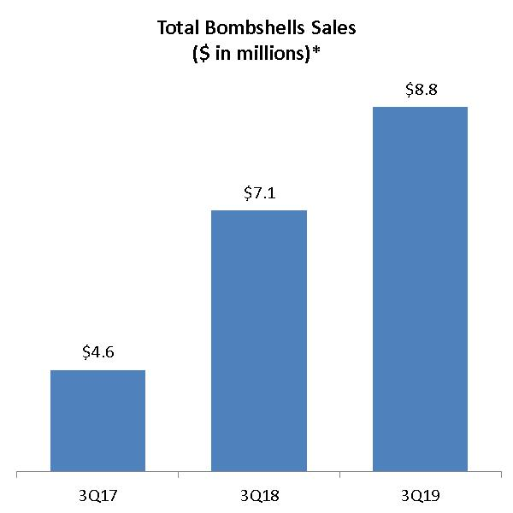
* Current and historical Nightclubs and Bombshells sales data do not include revenues from non-core operations.

CEO Comment

Eric Langan, President and CEO, commented: “New Nightclubs and Bombshells restaurants continued to perform very well in 3Q19, helping to generate record total club and restaurant sales.

“Looking at same-store sales, Nightclubs were slightly ahead year-over-year, which was particularly impressive given that it was on top of 3Q18’s 5.1% increase, while Bombshells continued to rebound, crossing over into positive year-over-year monthly comparisons in June 2019 for the first time in 12 months.

“During 3Q19, we also sold or leased four more non-income producing-properties in line with our capital allocation strategy. We hope to conclude the sale or lease of remaining non-income-producing properties by year-end FY19 or early FY20.”

1

Nightclubs

● | New clubs added $3.0 million from Rick’s Cabarets in Pittsburgh and Chicago (both acquired November 2018) and a smaller club in Kappa, IL (acquired at the end of May 2018 and part of same-store sales as of June 2019). Chicago is exceeding original expectations while Pittsburgh and Kappa are performing in line.
● | Strong same-store sales increases at clubs such as Hoops Cabaret and Sports Bar and Rick’s Cabaret in New York City, Downtown Cabaret and Rick’s Cabaret in Minneapolis, and Silver City Cabaret in Dallas and Rick’s Cabaret in Odessa, more than offset declines at Tootsies Cabaret and Scarlett’s Cabaret in the Miami area which did particularly well in 3Q18.
● | While Scarlett’s St. Louis was included in the total nightclubs count for 3Q19, it was closed due to a small fire in May 2019 and not included in same-store sales for May and June 2019. It expects to reopen soon after remodeling.

Bombshells

● | New units added $3.8 million from Houston area locations that opened April 2018 (Pearland), December 2018 (I-10), and March 2019 (Tomball). Two new Houston locations nearing completion (Katy and US 59) are on track to open this summer, giving the chain a total of 10 units in Texas.
● | The Bombshells Houston-Fuqua location was not included in same-store sales for June 2019 because it was closed temporarily in June 2018 as a consequence of a local matter that was subsequently resolved favorably.
● | On a sequential quarter basis, sales for all five locations open at least 18 months as of the end of 3Q19 increased 6.4% from 2Q19 to 3Q19, 5.5% from 1Q19 to 2Q19, and 4.1% from 4Q18 to 1Q19.

Other

● | During 3Q19, both the former Club Onyx and Foxy’s Cabaret locations in Dallas were leased out, and a small property in Lubbock, TX was sold.
● | Another parcel of excess Bombshells property, this one adjacent to the new I-10 location, was sold for a hotel development, and an excess aircraft was also sold. Proceeds from both of these sales were used to reduce associated debt.

Notes

● | Current and historical Nightclubs and Bombshells sales data in quarterly sales news releases do not include revenues from non-core operations.
● | Sales numbers are preliminary and subject to final closing.
● | Unit counts are at period end.
● | All references to the “company,” “we,” “our,” and similar terms include RCI Hospitality Holdings, Inc. and its subsidiaries, unless the context indicates otherwise.
● | Planned opening dates are subject to change due to weather, which could affect construction schedules, and scheduling of final municipal inspections.

About RCI Hospitality Holdings, Inc. (Nasdaq: RICK)

With more than 40 units, RCI Hospitality Holdings, Inc., through its subsidiaries, is the country’s leading company in gentlemen’s clubs and sports bars/restaurants. Clubs in New York City, Chicago, Dallas/Ft. Worth, Houston, Miami, Minneapolis, St. Louis, Charlotte, Pittsburgh, and other markets operate under brand names, such as Rick’s Cabaret, XTC, Club Onyx, Vivid Cabaret, Jaguars, Tootsie’s Cabaret, and Scarlett’s Cabaret. Sports bars/restaurants operate under the brand name Bombshells Restaurant & Bar. Please visit http://www.rcihospitality.com

2

Forward-Looking Statements

This press release may contain forward-looking statements that involve a number of risks and uncertainties that could cause the company’s actual results to differ materially from those indicated in this press release, including the risks and uncertainties associated with operating and managing an adult business, the business climates in cities where it operates, the success or lack thereof in launching and building the company’s businesses, risks and uncertainties related to cybersecurity, conditions relevant to real estate transactions, and numerous other factors such as laws governing the operation of adult entertainment businesses, competition and dependence on key personnel. The company has no obligation to update or revise the forward-looking statements to reflect the occurrence of future events or circumstances.

Media & Investor Contacts

Gary Fishman and Steven Anreder at 212-532-3232 or gary.fishman@anreder.com and steven.anreder@anreder.com

3

