United States
Securities and Exchange Commission
Washington, D.C. 20549

FORM 8-K

Current Report

Pursuant to Section 13 or 15(d) of

The Securities Exchange Act of 1934

Date of Report (Date of earliest event reported): January 9, 2020

RCI HOSPITALITY HOLDINGS, INC.
(Exact Name of Registrant as Specified in Its Charter)

Texas |  | 001-13992 |  | 76-0458229
(State or Other Jurisdiction  of Incorporation) |  | (Commission  File Number) |  | (IRS Employer  Identification No.)

10737 Cutten Road
Houston, Texas 77066
(Address of Principal Executive Offices, Including Zip Code)

(281) 397-6730
(Issuer’s Telephone Number, Including Area Code)

Check the appropriate box below if the Form 8-K filing is intended to simultaneously satisfy the filing obligation of the registrant under any of the following provisions:

[ ] | Written communications pursuant to Rule 425 under the Securities Act (17 CFR 230.425)
[ ] | Soliciting material pursuant to Rule 14a-12 under the Exchange Act (17 CFR 240.14a -12)
[ ] | Pre-commencement communications pursuant to Rule 14d-2(b) under the Exchange Act (17 CFR 240.14d -2(b))
[ ] | Pre-commencement communications pursuant to Rule 13e-4(c) under the Exchange Act (17 CFR 240.13e -4(c))

Securities registered pursuant to Section 12(b) of the Act:

Title of each class |  | Trading Symbol(s) |  | Name of each exchange on which registered
Common stock, $0.01 par value |  | RICK |  | The Nasdaq Global Market

Indicate by check mark whether the registrant is an emerging growth company as defined in Rule 405 of the Securities Act of 1933 (§230.405 of this chapter) or Rule 12b-2 of the Securities Exchange Act of 1934 (§240.12b-2 of this chapter).

Emerging growth company [ ]

If an emerging growth company, indicate by check mark if the registrant has elected not to use the extended transition period for complying with any new or revised financial accounting standards provided pursuant to Section 13(a) of the Exchange Act. [ ]

ITEM 2.02 | RESULTS OF OPERATIONS AND FINANCIAL CONDITION.

On January 9, 2020, we issued a press release announcing total and same-store sales at nightclubs and restaurants for the first fiscal quarter ended December 31, 2019. A copy of the press release is furnished as Exhibit 99.1 to this Current Report on Form 8-K.

This information shall not be deemed “filed” for purposes of Section 18 of the Securities Exchange Act of 1934, as amended (the “Exchange Act”), or incorporated by reference in any filing under the Securities Act of 1933, as amended, or the Exchange Act, except as shall be expressly set forth by specific reference in such a filing.

ITEM 9.01 | FINANCIAL STATEMENTS AND EXHIBITS

(d) Exhibits

Exhibit Number |  | Description
99.1 |  | Press release of RCI Hospitality Holdings, Inc. dated January 9, 2020

SIGNATURES

Pursuant to the requirements of the Securities Exchange Act of 1934, the registrant has duly caused this report to be signed on its behalf by the undersigned hereunto duly authorized.

 | RCI HOSPITALITY HOLDINGS, INC.
Date: January 10, 2020 | By: | /s/ Eric Langan
 |  | Eric Langan
 |  | President and Chief Executive Officer

Exhibit 99.1



RCI 1Q20 Club & Restaurant Total Sales Up 10.1% to a Record $47.8 Million

HOUSTON—January 9, 2020—RCI Hospitality Holdings, Inc. (Nasdaq: RICK) today announced sales for its Nightclubs and Bombshells restaurants for the Fiscal 2020 first quarter ended December 31, 2019.

1Q20 vs. 1Q19

● | Total club and restaurant sales: $47.8 million compared to $43.4 million – up 10.1%
● | Consolidated same-store sales: $39.7 million compared to $39.5 million – up 0.7%
● | Nightclubs total sales: $37.4 million compared to $37.4 million (38 units vs. 39) – up 0.1%
● | Nightclubs same-store sales: $34.2 million compared to $34.8 million – down 1.8%
● | Bombshells total sales: $10.3 million compared to $6.0 million (9 units vs. 7) – up 72.1%
● | Bombshells same-store sales: $5.5 million compared to $4.6 million – up 19.2%

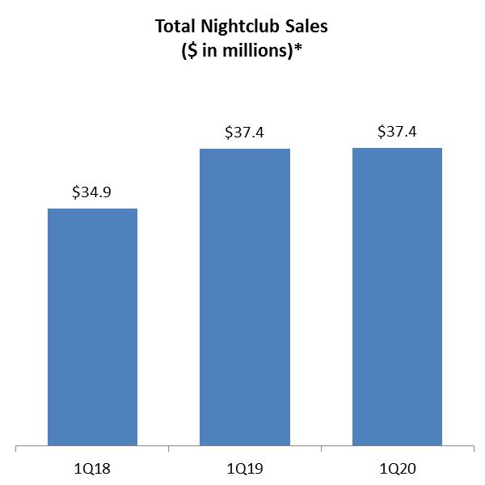 | 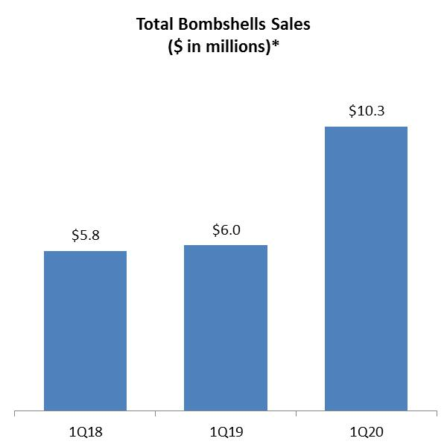 | 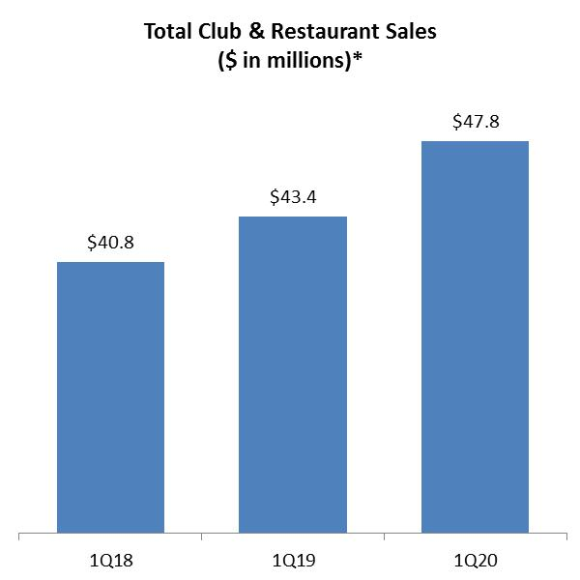
* Current and historical Nightclubs and Bombshells sales data do not include revenues from non-core operations.

CEO Comment

Eric Langan, President and CEO, said: “Total sales were up 10%, which was good. It was a great quarter for Bombshells. Same-store sales continued to rebound, new Bombshells continued to do very well, and we benefitted from the Houston Astros in the playoffs. Nightclubs did okay. New clubs continued to perform well, two moderate sized clubs were closed part of the quarter, we had one less prime revenue week, and we were comping against year ago increases of 7% in total sales and 4% in same-store sales.”

Nightclubs

● | New clubs added $2.9 million from Rick’s Cabarets in Pittsburgh and Chicago (both acquired November 2018).
● | Scarlett’s Cabaret St. Louis enjoyed a successful reopening in late November-early December after being closed for remodeling after a fire in May.
● | Rick’s Cabaret Odessa was closed for less than half a month in October for maintenance.
● | There were three full weeks between Thanksgiving and Christmas in 1Q20 versus four in 1Q19. These weeks are typically a large seasonal period for Nightclubs.

1

Bombshells

● | Contribution from new units increased 249.7% to $4.8 million in 1Q20 from four Houston area locations—Pearland (opened April 2018), I-10 (December 2018), Tomball (March 2019), and a partial quarter of Katy (October 22, 2019), which experienced a record month for a Bombshells in November.
● | All of the “first five” locations were included in the 19.2% same-store sales increase in 1Q20 and in 1Q19.
● | Similar to 1Q18, most locations in 1Q20 benefitted from increased traffic as a result of the Houston Astros playing through the 7th game of the championship series.
● | An upcoming Houston location on US 59 is anticipated to open this month, which would expand the chain to a total of 10 units in Texas.

Notes

● | Current and historical Nightclubs and Bombshells sales data in quarterly sales news releases do not include revenues from non-core operations.
● | Sales numbers are preliminary and subject to final closing.
● | Unit counts are at period end.
● | All references to the “company,” “we,” “our,” and similar terms include RCI Hospitality Holdings, Inc. and its subsidiaries, unless the context indicates otherwise.
● | Planned opening dates are subject to change due to weather, which could affect construction schedules, and scheduling of final municipal inspections.

About RCI Hospitality Holdings, Inc. (Nasdaq: RICK)

With more than 40 units, RCI Hospitality Holdings, Inc., through its subsidiaries, is the country’s leading company in gentlemen’s clubs and sports bars/restaurants. Clubs in New York City, Chicago, Dallas/Ft. Worth, Houston, Miami, Minneapolis, St. Louis, Charlotte, Pittsburgh, and other markets operate under brand names such as Rick's Cabaret, XTC, Club Onyx, Vivid Cabaret, Jaguars Club, Tootsie’s Cabaret, and Scarlett’s Cabaret. Sports bars/restaurants operate under the brand name Bombshells Restaurant & Bar. Please visit http://www.rcihospitality.com/

Forward-Looking Statements

This press release may contain forward-looking statements that involve a number of risks and uncertainties that could cause the company’s actual results to differ materially from those indicated in this press release, including, but not limited to, the risks and uncertainties associated with (i) operating and managing an adult business, (ii) the business climates in cities where it operates, (iii) the success or lack thereof in launching and building the company’s businesses, (iv) cyber security, (v) conditions relevant to real estate transactions, (vi) our ability to regain and maintain compliance with the filing requirements of the SEC and the Nasdaq Stock Market, and (vii) numerous other factors such as laws governing the operation of adult entertainment businesses, competition and dependence on key personnel. The company has no obligation to update or revise the forward-looking statements to reflect the occurrence of future events or circumstances.

Media & Investor Contacts

Gary Fishman and Steven Anreder at 212-532-3232 or gary.fishman@anreder.com and steven.anreder@anreder.com

2

