United States
Securities and Exchange Commission
Washington, D.C. 20549

FORM 8-K

Current Report

Pursuant to Section 13 or 15(d) of

The Securities Exchange Act of 1934

Date of Report (Date of earliest event reported): October 8, 2020

RCI HOSPITALITY HOLDINGS, INC.
(Exact Name of Registrant as Specified in Its Charter)

Texas |  | 001-13992 |  | 76-0458229
(State or Other Jurisdiction  of Incorporation) |  | (Commission  File Number) |  | (IRS Employer  Identification No.)

10737 Cutten Road
Houston, Texas 77066
(Address of Principal Executive Offices, Including Zip Code)

(281) 397-6730
(Issuer’s Telephone Number, Including Area Code)

Check the appropriate box below if the Form 8-K filing is intended to simultaneously satisfy the filing obligation of the registrant under any of the following provisions:

☐ | Written communications pursuant to Rule 425 under the Securities Act (17 CFR 230.425)
☐ | Soliciting material pursuant to Rule 14a-12 under the Exchange Act (17 CFR 240.14a -12)
☐ | Pre-commencement communications pursuant to Rule 14d-2(b) under the Exchange Act (17 CFR 240.14d -2(b))
☐ | Pre-commencement communications pursuant to Rule 13e-4(c) under the Exchange Act (17 CFR 240.13e -4(c))

Securities registered pursuant to Section 12(b) of the Act:

Title of each class |  | Trading Symbol(s) |  | Name of each exchange on which registered
Common stock, $0.01 par value |  | RICK |  | The Nasdaq Global Market

Indicate by check mark whether the registrant is an emerging growth company as defined in Rule 405 of the Securities Act of 1933 (§230.405 of this chapter) or Rule 12b-2 of the Securities Exchange Act of 1934 (§240.12b-2 of this chapter).

Emerging growth company ☐

If an emerging growth company, indicate by check mark if the registrant has elected not to use the extended transition period for complying with any new or revised financial accounting standards provided pursuant to Section 13(a) of the Exchange Act. ☐

ITEM 2.02 | RESULTS OF OPERATIONS AND FINANCIAL CONDITION.

On October 8, 2020, we issued a press release announcing sales at nightclubs and restaurants for the fourth fiscal quarter and fiscal year ended September 30, 2020. The press release also provided an update on the status of nightclub and restaurant openings and other company and financial matters in connection with the COVID-19 pandemic. A copy of the press release is furnished as Exhibit 99.1 to this Current Report on Form 8-K.

This information shall not be deemed “filed” for purposes of Section 18 of the Securities Exchange Act of 1934, as amended (the “Exchange Act”), or incorporated by reference in any filing under the Securities Act of 1933, as amended, or the Exchange Act, except as shall be expressly set forth by specific reference in such a filing.

ITEM 9.01 | FINANCIAL STATEMENTS AND EXHIBITS

(d) Exhibits

Exhibit Number |  | Description
99.1 |  | Press release of RCI Hospitality Holdings, Inc. dated October 8, 2020

SIGNATURES

Pursuant to the requirements of the Securities Exchange Act of 1934, the registrant has duly caused this report to be signed on its behalf by the undersigned hereunto duly authorized.

 | RCI HOSPITALITY HOLDINGS, INC.
Date: October 8, 2020 | By: | /s/ Eric Langan
 |  | Eric Langan
 |  | President and Chief Executive Officer

Exhibit 99.1



RCI Reports 4Q20 Club & Restaurant Sales, Reflecting Continued Rebound

HOUSTON—October 8, 2020—RCI Hospitality Holdings, Inc. (Nasdaq: RICK) today reported sales for its Nightclubs and Bombshells restaurants for the Fiscal 2020 fourth quarter ended September 30, 2020. Results reflect continued rebound from April when all locations were closed due to the Covid-19 pandemic.

Highlights

● | Total club and Bombshells sales of $28.4 million in 4Q20 (up 98.5% from 3Q20) with 24 locations open the duration of the quarter and 44 by period end. FY20 club and Bombshells sales totaled $130.3 million.
● | Bombshells sales of $15.5 million in 4Q20 (up 82.1% from 3Q20) with 8 of 10 locations open the duration of the quarter. FY20 Bombshells sales totaled $43.2 million. Same-store sales increased 50.4% and 18.3% for 4Q20 and FY20, respectively, from the prior year.
● | Club sales of $12.9 million in 4Q20 (up 122.7% from 3Q20) with 16 locations open the duration of the quarter and 34 by period end. FY20 club sales totaled $87.1 million. Same-store sales declined only 13.2% and 9.0% for 4Q20 and FY20, respectively, from the prior year.
● | As of today, 46 of 48 locations are open (10 Bombshells and 36 clubs). The five large clubs in Florida and New York City reopened at the end of 4Q20. One of the two clubs not open is a smaller Louisiana location damaged by a recent hurricane, covered by insurance, and planned to be rebuilt.
● | All locations continue to limit occupancy in accordance with Covid safety plans. Not all clubs are operating at full schedules, in line with other government restrictions. Some above-mentioned locations open all three months in 4Q20 were closed a few days for deep cleaning.

Also, during 4Q20, Gentlemen’s Club EXPO, the industry’s national convention, tradeshow and awards, was rescheduled to May 2021 in Miami from October 2020 in Las Vegas.

CEO Comment

Eric Langan, President & CEO, said, “We are excited to have 46 of 48 locations open with both employees and entertainers back at work and being able to provide for their families again.

“The geographic and format diversity of our locations, the resiliency of our businesses, and the agility of our teams continue to prove successful. The Bombshells chain is doing fantastic even as other restaurants reopen in Texas. Recently initiated third-party delivery services also contributed to Bombshells’ 4Q20 sales. In addition, most clubs are continuing to demonstrate their ability to steadily rebuild customer traffic after reopening.

“Cash is building. We are pleased to be back in the hunt for new Bombshells locations and club acquisitions, and we are reviewing proposals to refinance our real estate debt to take advantage of the increased value of our new Bombshells locations and lower interest rates.

“We greatly appreciate the loyalty of our customers. Special thanks to our team members for making all our successes possible. All customers are urged to continue to wear masks and follow Covid-related guidelines wherever they go so we can stay safe, remain open, serve our guests, and keep our team members working.

“We anticipate filing our 10-K and reporting full 4Q20 and FY20 financial results by December 14.”

1

Total Club & Restaurant Sales ($ in millions)

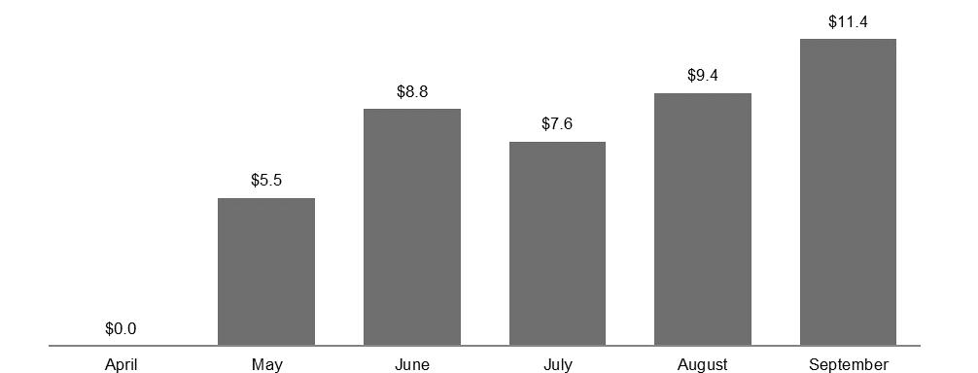

 |  | April |  |  |  | May |  |  |  | June |  |  |  | July |  |  |  | August |  |  |  | September
Nightclubs |  | $ | 0.0 |  |  | $ | 1.2 |  |  | $ | 4.6 |  |  | $ | 2.9 |  |  | $ | 4.0 |  |  | $ | 6.0
Bombshells |  | $ | 0.0 |  |  | $ | 4.3 |  |  | $ | 4.2 |  |  | $ | 4.7 |  |  | $ | 5.4 |  |  | $ | 5.4
Total |  | $ | 0.0 |  |  | $ | 5.5 |  |  | $ | 8.8 |  |  | $ | 7.6 |  |  | $ | 9.4 |  |  | $ | 11.4

 |  |  | 3Q20 |  |  |  | 4Q20 |  |  | 4Q vs.3Q Δ |  |  |  | FY20
Nightclubs |  | $ | 5.8 |  |  | $ | 12.9 |  |  | +122.7 | % |  | $ | 87.1
Bombshells |  | $ | 8.5 |  |  | $ | 15.5 |  |  | +82.1 | % |  | $ | 43.2
Total |  | $ | 14.3 |  |  | $ | 28.4 |  |  | +98.5 | % |  | $ | 130.3

● | Sales do not include non-core operations and are preliminary and subject to final closing.
● | Due to Covid-related closures, not all locations were open enough days, among other factors, to be included in 4Q20 same-store sales calculations, which also affected FY20 SSS calculations.
● | All references to “RCI Hospitality Holdings, Inc.”, “company,” “we,” “our,” and similar terms refer to RCI and/or its subsidiaries, unless the context indicates otherwise.

Forward-Looking Statements

This press release may contain forward-looking statements that involve a number of risks and uncertainties that could cause the company’s actual results to differ materially from those indicated in this document, including, but not limited to, the risks and uncertainties associated with (i) operating and managing adult businesses, (ii) the business climates in cities where it operates, (iii) the success or lack thereof in launching and building the company’s businesses, (iv) cyber security, (v) conditions relevant to real estate transactions, (vi) the impact of the coronavirus pandemic, and (vii) numerous other factors such as laws governing the operation of adult entertainment businesses, competition and dependence on key personnel. The company has no obligation to update or revise the forward-looking statements to reflect the occurrence of future events or circumstances.

Media & Investor Contacts

Gary Fishman and Steven Anreder at 212-532-3232 or gary.fishman@anreder.com and steven.anreder@anreder.com

2

